GoTechnology®

hub2

User Guide

TABLE OF CONTENTS

1. About 2

2. UI 4

3. Levels 8

4. Permissions 17

5. Beyond Levels: The Extended Logical Structure of hub2 19

6. Populating Data 21

7. Handovers 31

8. Preservation 34

9. Assurance 36

10. Reports 44

11. What order do I load the data in? 54

12. Glossary / Listing 56

# About

### Introduction

This user guide describes an introduction or reference guide for some of the more complex features of GoTechnology hub2; Wood’s next generation completions and commissioning management solution.

The document contains screen shots and information that were relevant at the time of release. As GoTechnology hub2 is a continuously developed product the actual appearance or function may differ from what is depicted.

In addition, some sections or operations shown may not be accessible due to permissions issues.

For the latest information on GoTechnology please visit <http://qedi-gotechnology.github.io> or contact [commissioning.info@woodplc.com](mailto:commissioning.info@woodplc.com)

### Intended Audience

It’s expected that readers will have completed the required training courses, and understand the fundamental concepts and basic operations, before reading this document.

This guide is intended for authorised users only and should not be distributed without the express consent of Wood.

### GoTechnology hub2

First released in October 2017, hub2 is the latest generation of Wood’s GoTechnology family of online, web-accessible completions and commissioning management solutions.

Intended as a replacement for all previous products within the range, hub2 delivers the facilities to track, record and report on details of equipment, certification, handovers, procedures, preservation routines and Job Card information, amongst others.

#### Access

Details of how to access GoTechnology hub2 will be provided separately. Please note: As hub2 is a primarily online solution, an internet connection and a modern, HTML5 compliant web browser are required.

### Glossary of Terms / Listing of Information

At the end of this document is an abbreviated list of the information stored within hub2, where it can be viewed from, and which Level within the information hierarchy (described in 3 Levels below) it resides.

Important Note: This is not a complete listing and is intended for basic reference purposes to the most commonly used areas of GoTechnology hub2. Client, industry or process specific information types will be excluded for this reason.

# UI

Let’s take a look at the User Interface (or UI) for hub2. This is the “look and feel” of the application: How information is displayed onscreen and how you interact with it.

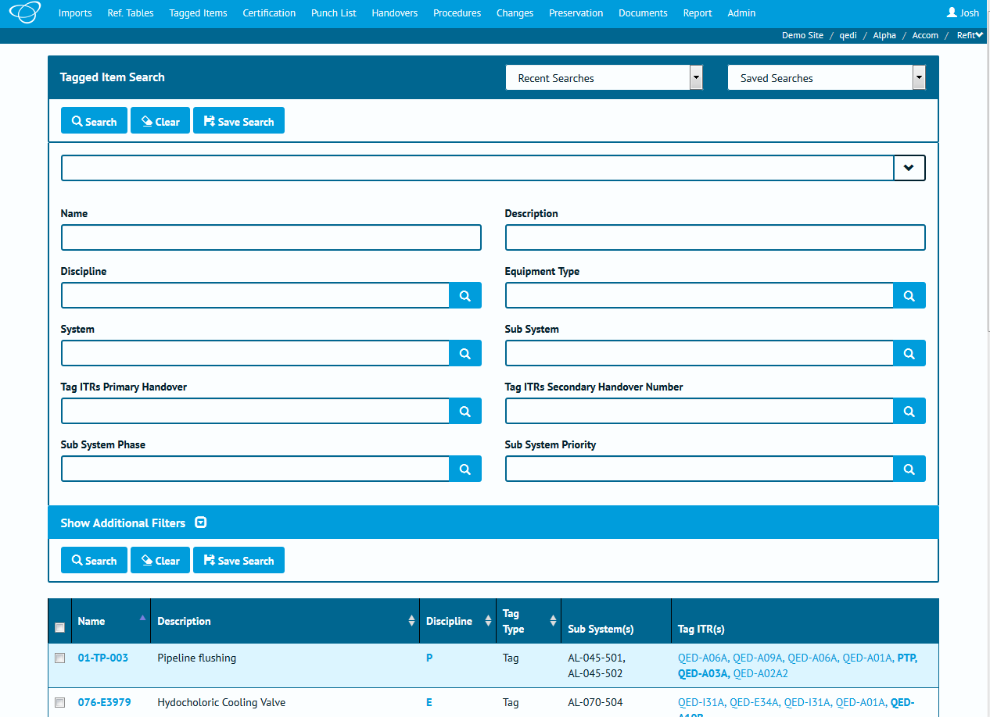

Depending on which version of hub2, your preferences, permissions and configuration, and the device your viewing on, some elements may appear differently, or not at all.

If we apply some highlighting to some different elements on this screen we can cover a lot of the basic concepts within hub2, which follow all the way through the application.

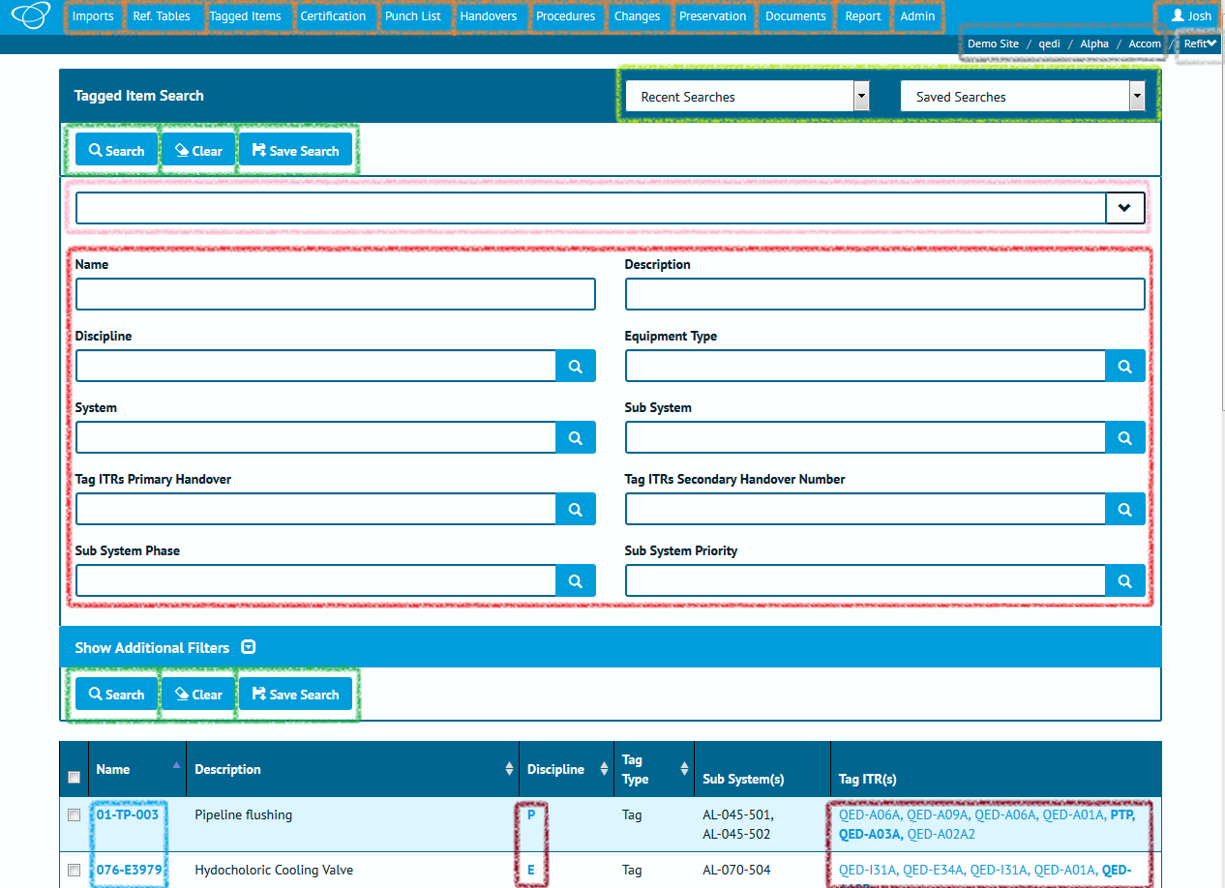

|  |  |  |  |
| --- | --- | --- | --- |
| Colour | Location | Element | Description |
| **◼** | Top of screen (menu bar) |  | The top menu buttons are the key to navigating hub2. Clicking one of these buttons will open a drop-down menu with links to specific pages.  This includes the button at the top right, which displays your name (or the name of whoever is currently logged in) and provides links to User preferences and options. |
| **◼** | Top Right |  | The navigation “breadcrumbs” show which Level A / Level B / Level C / Level D you’re currently logged in to. Click any of these elements will take you back to the Level select screen. |
| **◼** | Top Right |  | The final breadcrumb element represents the Level E. Clicking this will provide a drop-down of other Level E’s within this Level D, allowing you to quickly switch between them. |
| **◼** | Search Header |  | A drop-down menu that provides the five most recent searches you’ve run, allowing you to re-run them easily. |
|  | Lists any “Saved Searches” you have created via the “Save Search” button. |
| **◼** | Various locations, throughout hub2 |  | Buttons within hub2 have many purposes but are mainly used to trigger an action, whether it’s to start a search or import, add or delete an item, or, in the case of the button shown to the left, clear all the values from a form. |
| **◼** | Near the top of the search form |  | The quick search bar can be used to enter multiple search fields in one place.  In addition, the drop-down arrow, when clicked, provides a list of field definitions. |
| **◼**  Various locations,  throughout hub2 | |  | Input fields can be used to enter search terms or add data.  This can be either typed directly, or in the case of dates, selected from a date picker. |
|  | For “lookup” fields, the magnifying glass button on the right can be clicked to open a popup containing all the possible values that can be selected.  Alternatively, a value can be typed in directly as normal. |
|  | Fields which are “Required” have the word *Required* shown when they are empty.  When a field is Required it means that it won’t be possible to add a new record if those fields are blank or contain invalid information (and hub2 will tell you if the information is invalid). |

# Levels

Within hub2 project information is stored in five connected levels. This might seem like a more complex approach than you’re used to before, but once we’ve explained it, you’ll understand how it’s easy to use, and will save time and improve consistency of data. Within the structure, inheritance is used: Information defined in the first level flows throw to the second, third, fourth and fifth levels, information in the second flows throws to the third, fourth and fifth level, and so on.

Within this document, we will refer to these levels as Level A, Level B, Level C, Level D and Level E, however they can be renamed by yourself or your hub2 administrator to use names that are much more relevant to your project or industry.

Here’s an example of how an instance of hub2 might be laid out. Don’t worry too much about the details at this stage, we’ll go into those later!

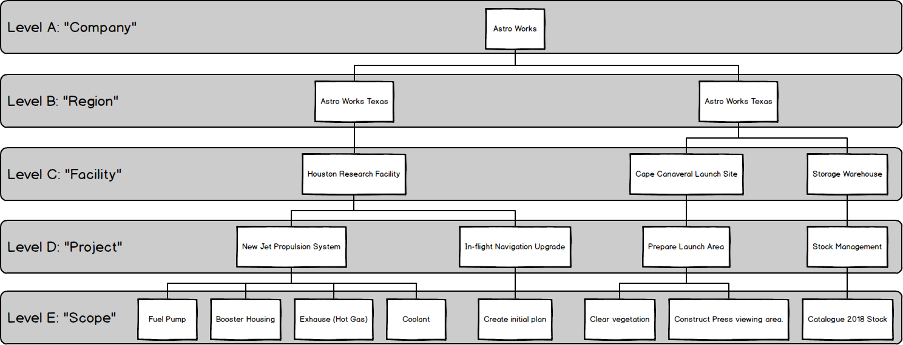

As you can see, in the above picture we have a fictional company named “Astro Works”, and a data structure that’s been designed in hub2 to best support their operations. This structure will allow the Astro Works teams to share the information they need, while making it clear who is working on what, and ensuring that any information is only available to the appropriate persons.

So how do we build up a structure like that, and what do these levels really represent? We’ll get into that in a second, but before we do, an important point.

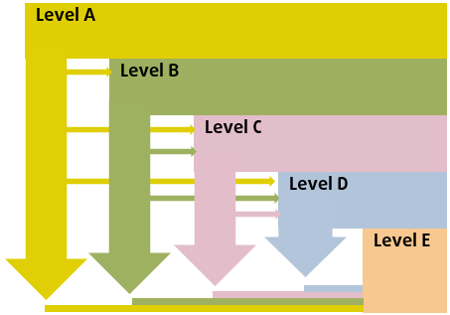

An Important Point about Levels

You (or your hub2 administrator) can change your Level configuration whenever you need to, so don’t worry about having to get it right first time.

If you’d like some advice on Level configuration, just get in touch. We’re here to help!

## Thinking about Levels

When it comes time to build up our data within hub2, we start at the “top” of the data hierarchy (Level A) and work our way down from there.

### Level A

As we know, Level A represents the “Company”, “Corporate” or “Global” level. It contains configuration options that will be utilised **in every part of the world, in every industry, on every project and work scope** the company does… Or at least that’s the idea! Of course, in reality this may not be practical, but we’ll discuss that later.

For now, let’s assume that there’s just one item in Level A representing the whole company. In our example case, that is Astro Works, our fictional space exploration organisation.

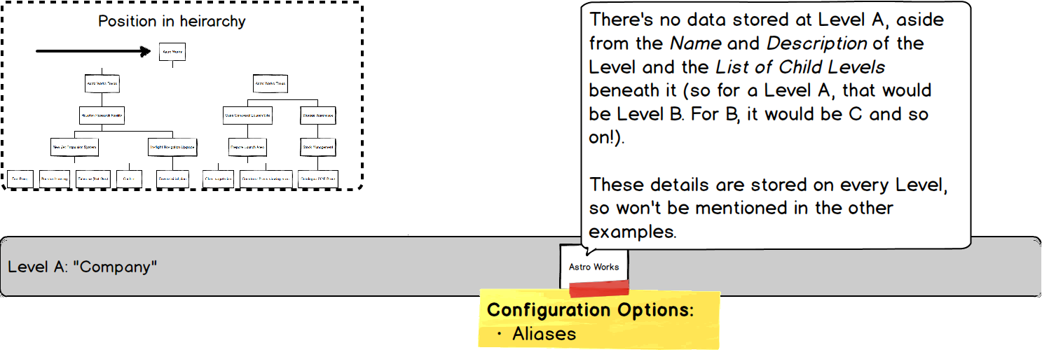

There’s no data stored at this level, but there are some options:

* Aliases

Aliases allow us to “rename” certain items on screen. As we’ve mentioned these can include the Levels themselves, as well as other items such as Certification Grouping. When we set an Alias for any field then the default name is replaced by the alias we’ve chosen.

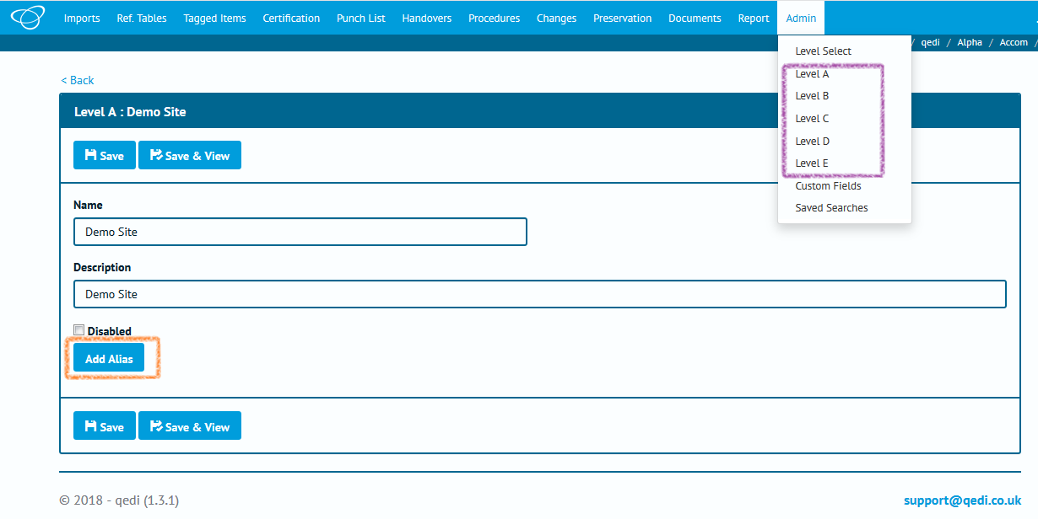

In the above screenshot, the orange highlight shows that there are no Alias at present, just the “Add Alias” button. The purple highlight shows that the default “Level A” to “Level E” are shown.

Let’s rename those to some more friendly values.

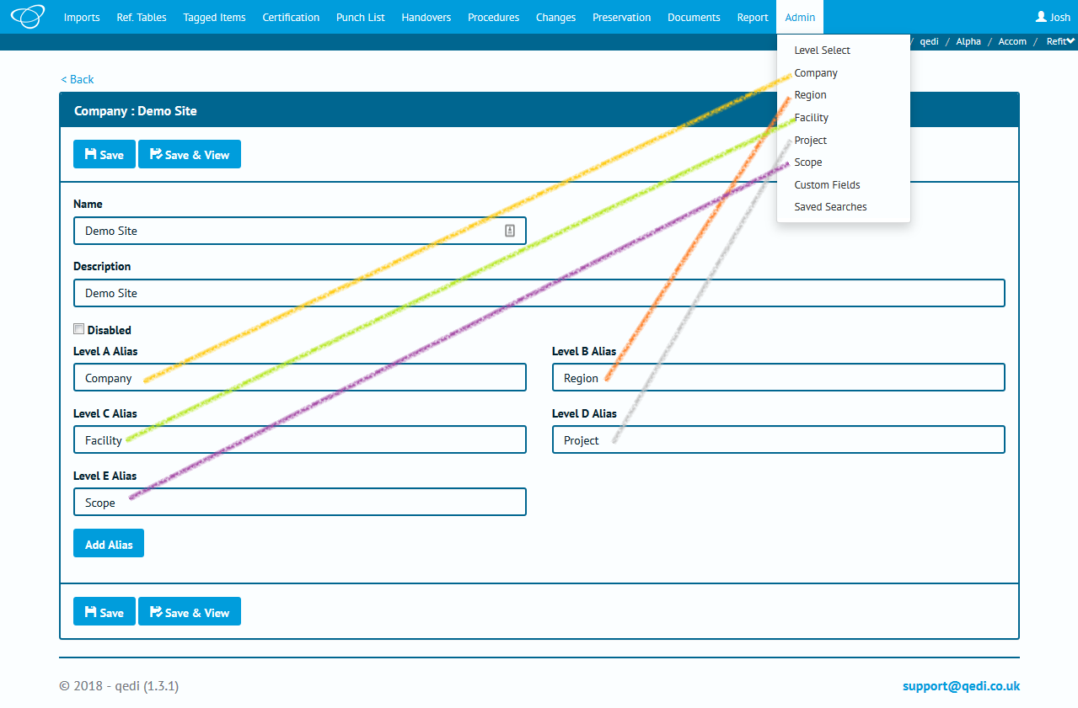

Once we save we can see the menu has updated too.

### Level B

Level B represents the first sub-division of the structure and is the first place we can actually store data. It’s usually used to represent a region, division or industry sector.

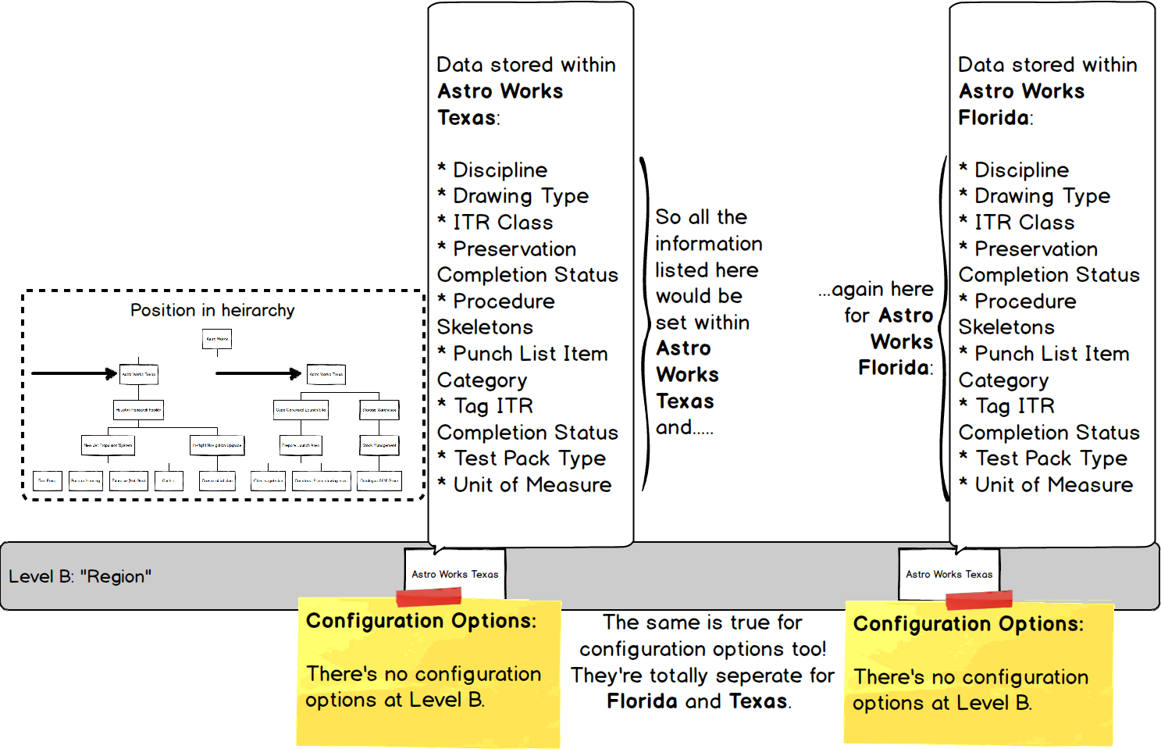

#### Information at Level B

The kind of information we store at this Level is very high level

Remember, any information set here will be used by the associated levels below:

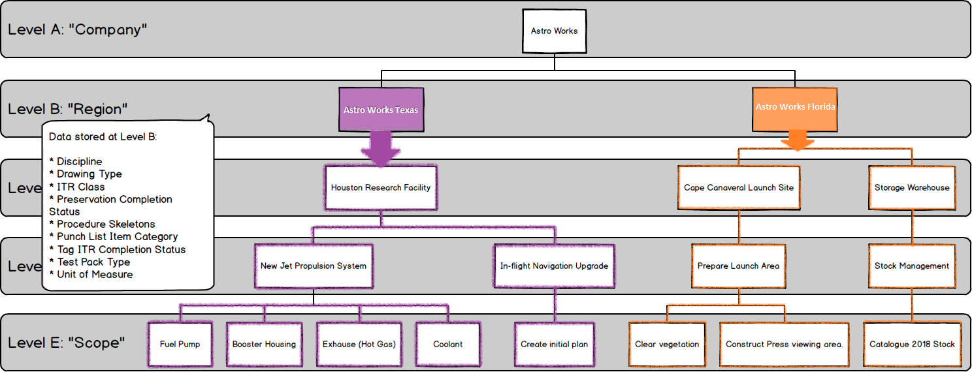

In the above picture we can see our two Level B’s (which we’re calling “Regions”) **Astro Works Texas** and **Astro Works Florida**, containing different information (which is shown by having one in purple and one in orange).

The solid colour indicates where the information is set, with the outlining showing where the information is used or referenced from.

As you would expect from our previous explanations, Levels below, reference the information defined in those above (by now we’re hoping this is becoming painfully obvious, and even repetitive, to you.

### Level C

Level C is usually used to represent a physical construction or geographic area in which multiple projects (which themselves have multiple scopes of work) are being (or will be) executed.

As such it contains a large amount of data, as well as a few key configuration options:

* Preservation Progress Method
* Preservation Window Before
* Preservation Window After

These are described in more detail, and in context, in 8 Preservation.

Let’s go back to our diagram and take a look at Level C in more detail

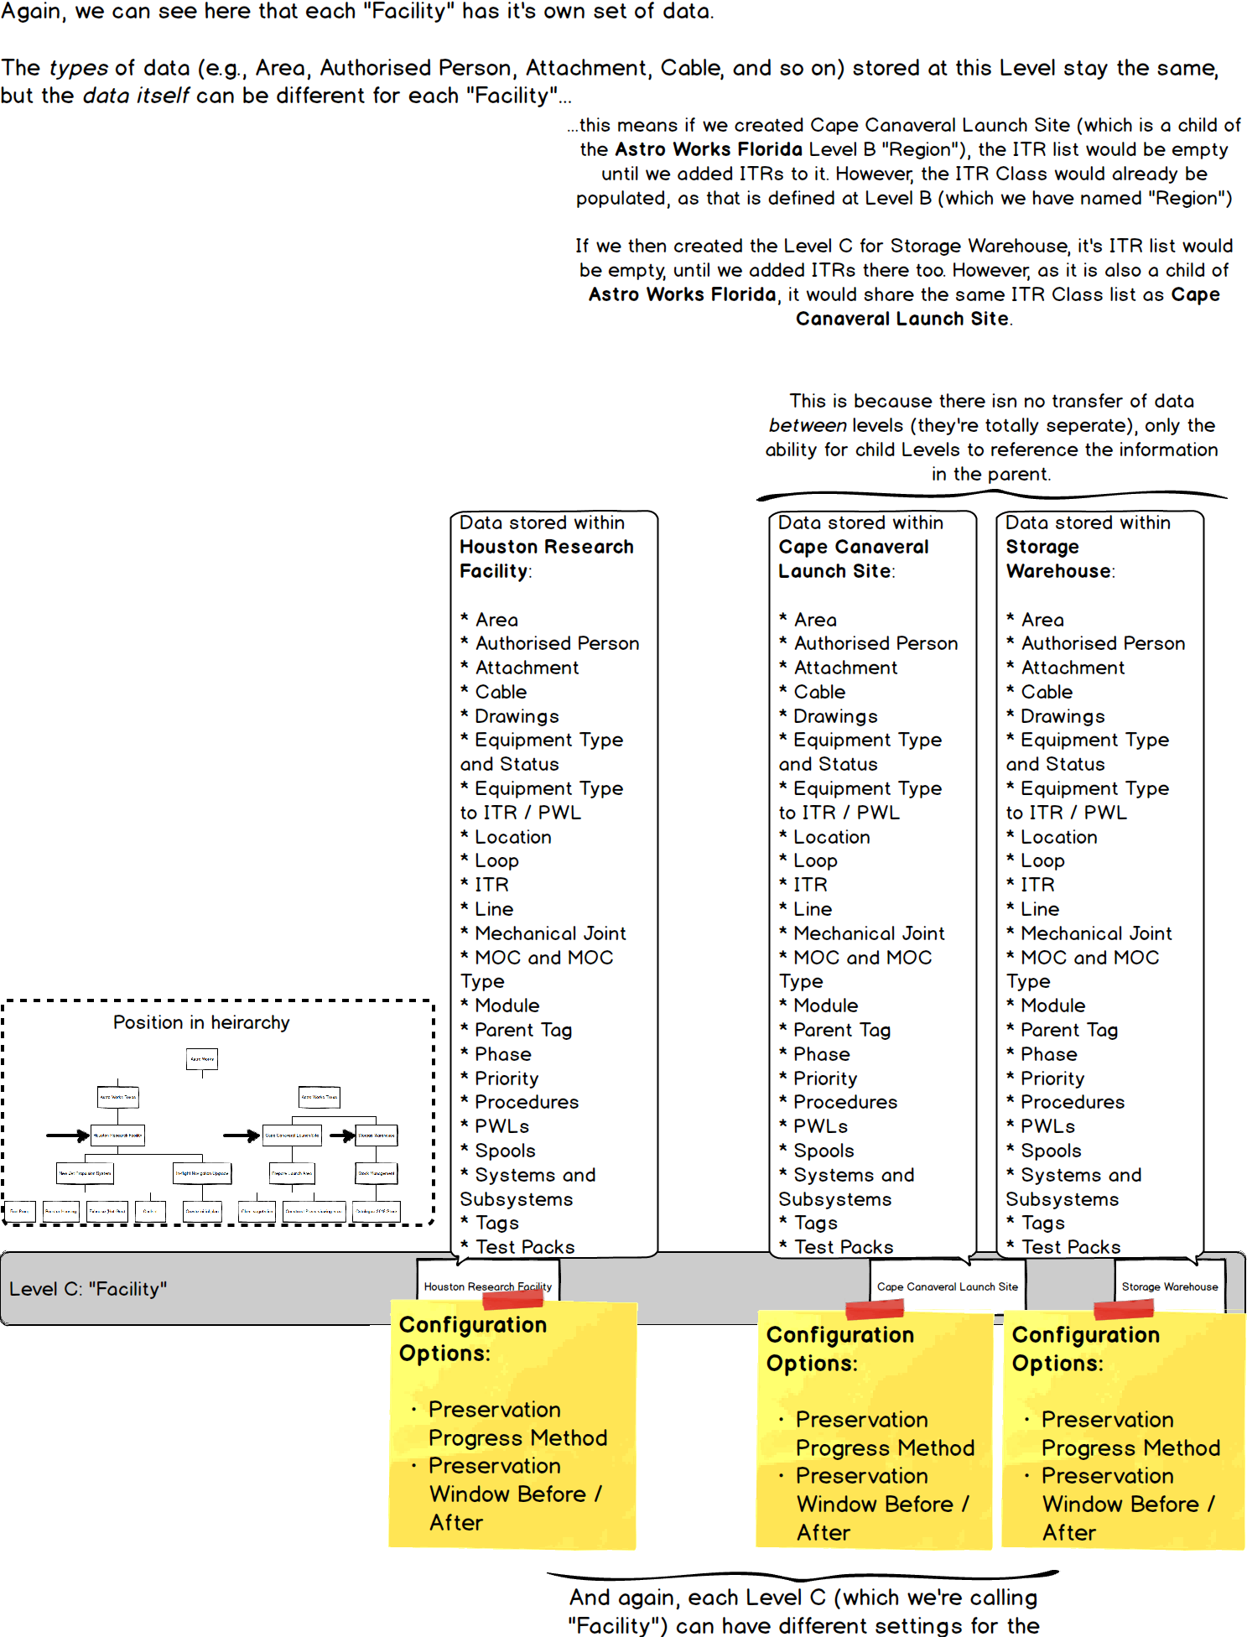

Just to repeat our previous point once more, the information set at Level C, will be utilised by the levels below:

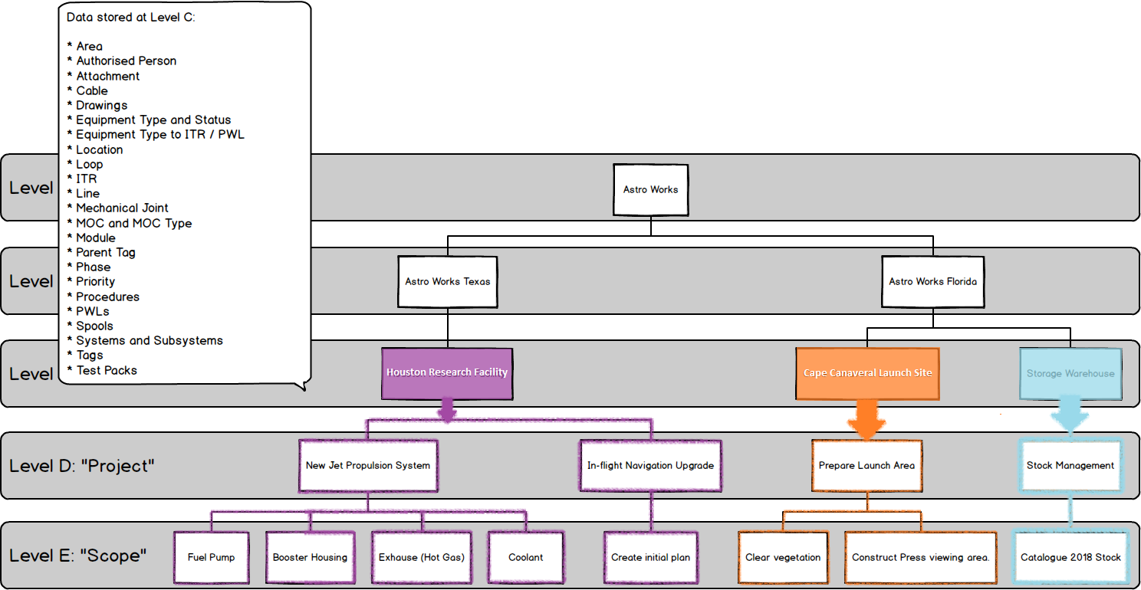

### Level D

Level D is the “Project” level, and represents a grouping of work scopes (which are recorded at Level E). As such, there’s not too much data stored here and, aside from the logos which appear on reports and certification, only one setting:

* Punch List Item Auto Number – Set whether Punch List numbers are generated automatically, and any conventions/formats for that number.

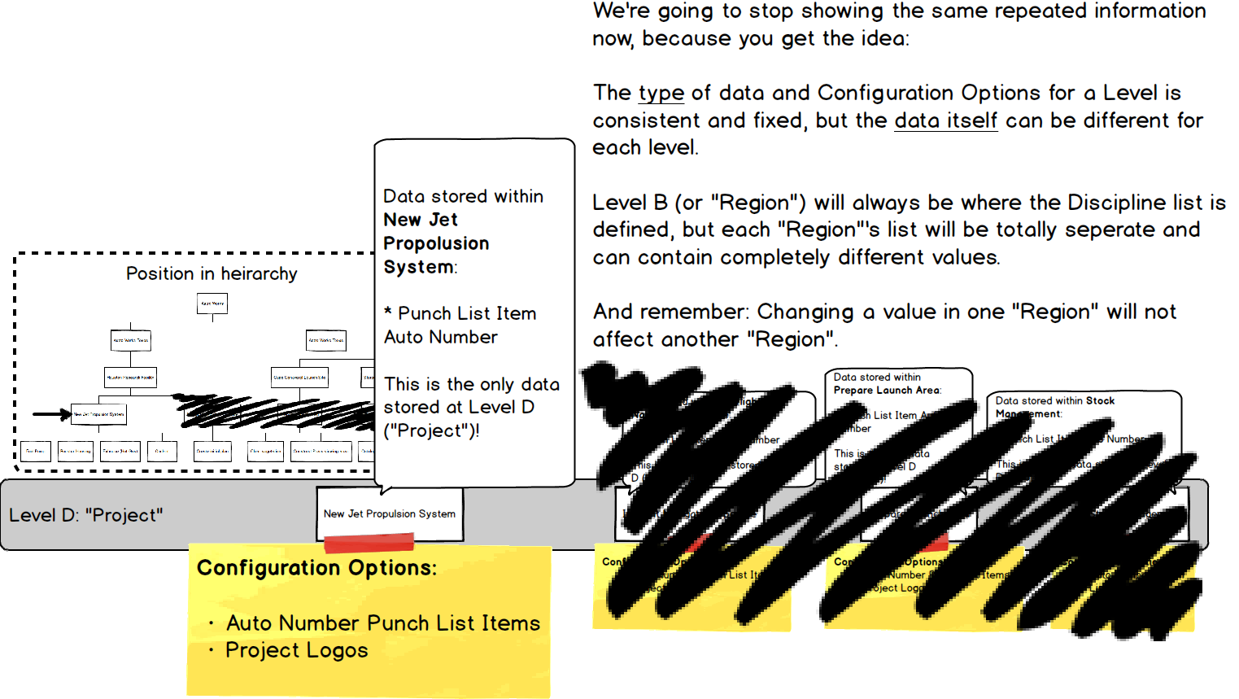

As we know, the information at a higher Level is referenced by those beneath it. This time we’ll show the structure without highlighting. Can you imagine which Level E’s inherit from where?

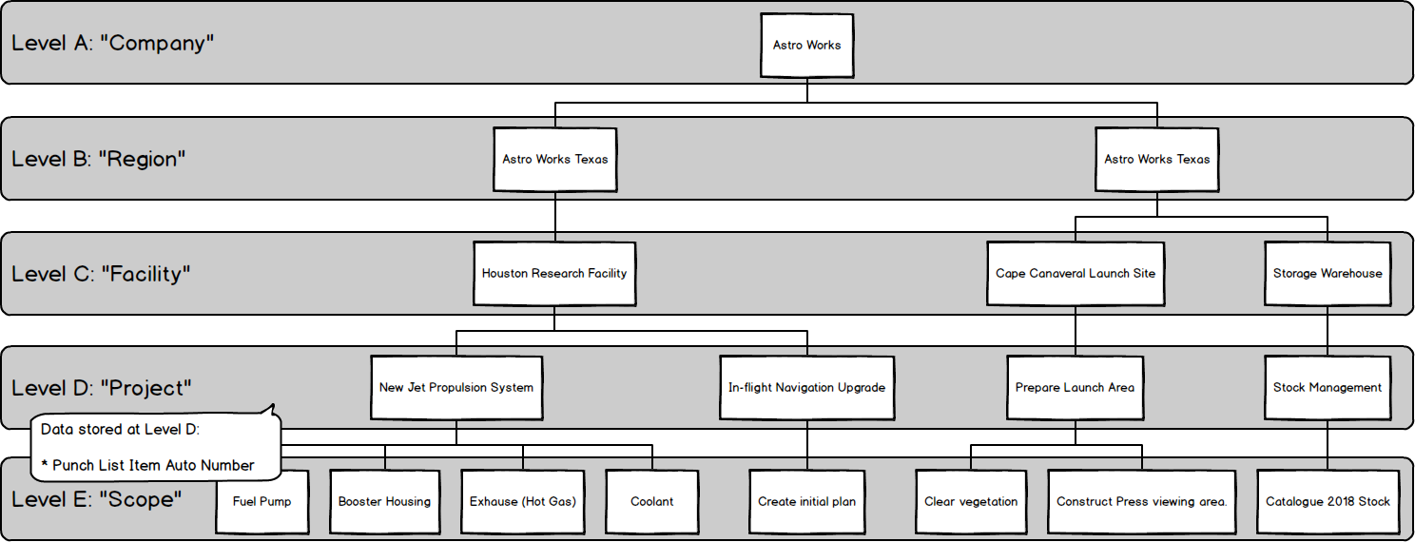

We’re sure you figured it out – it’s just a case of tracing the lines.

### Level E

Level E represents the scope of work – it’s where sign-offs are stored and progress is recorded.

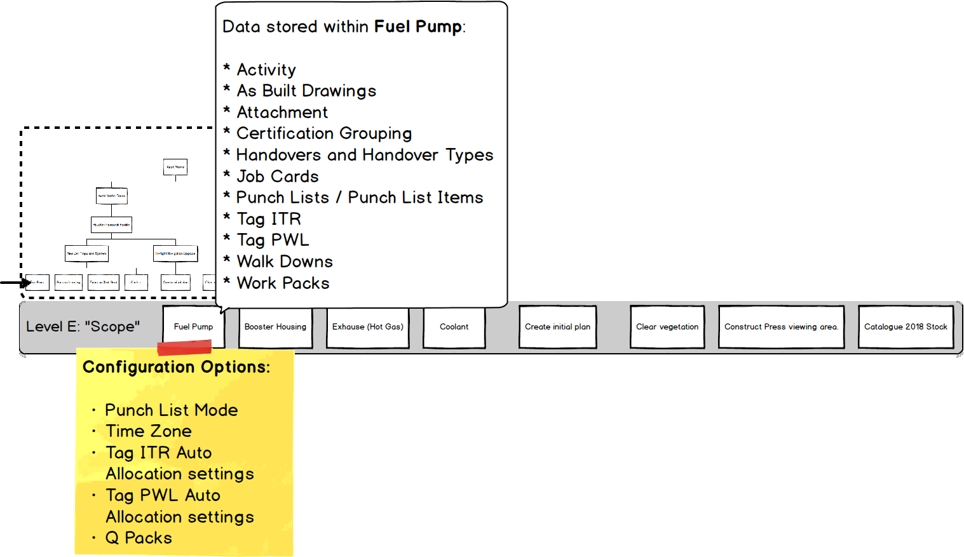

Level E is the lowest level, so any of our Level E’s (or “Scopes” as we’ve aliased them) won’t affect anything other than themselves.

# Permissions

Certain standard levels are provided in GoTechnology hub2, however we can also create Custom Permissions for you too.

## Standard User Levels

The following Standard User Levels are available within GoTechnology hub2:

**NOTE: It is possible for you or your focal point to restrict sign-off by discipline (for example a Commissioning Tech that can only sign off Electrical Tag ITRs)**

|  |  |  |  |  |  |
| --- | --- | --- | --- | --- | --- |
|  | Can Add: | Can Edit: | Can Delete: | Can Sign-off: | Special abilities: |
| Admin | All | All | All | All | Custom Fields  Digital Document Templates  Enter any name against Sign-Off  Import |
| Commissioning Engineer | Attachments  Procedures  Punch Lists  Tag ITRs | Procedures  Tag ITRs | Procedures  Tag ITRs | All | Custom Fields  Digital Document Templates  Import |
| Commissioning Technician | Attachments  Punch Lists | None | None | Job Cards  MOC  Procedures  Punch Lists  Tag ITRs  Tag PWLs  Work Packs |  |
| Completions Engineer | All | All | All | All | Custom Fields  Digital Document Templates  Import |
| Management | Attachments | None | None | All |  |
| Operations Supervisor | Attachments  Handovers  Tags | Handovers  Tags | Handovers  Tags | All |  |
| Project Engineer | None | None | None | MOC  Procedures  Punch Lists  Work Packs |  |
| Read Only | None | None | None | None |  |
| Supervisor | Punch Lists | None | None | All |  |
| TA | Attachments  Punch Lists | None | None | All |  |
| Technician | Attachments  Punch Lists | None | None | Job Cards  Punch Lists  Tag ITRs  Tag PWLs  Work Packs |  |
| Work Pack Engineer | Punch Lists  Tags  Tag ITRs  Work Packs | Tags  Tag ITRs  Work Packs | Tags  Tag ITRs  Work Packs | All |  |

## Custom User Levels

Permissions within GoTechnology hub2 have a high level of flexibility: Authorisation can be fine-tuned for almost every table, to specify if a User can Add, Update, Delete or even see it at all. There are also additional special permissions for certain tables, such as the ability to sign-off Tag ITRs or Tag PWLs.

If any customisation to roles or permissions are required, just ask!

# Beyond Levels: The Extended Logical Structure of hub2

Now we know all about Levels, what’s stored there and how we can set up the right permissions, but what happens when we go **deeper**? How is information within a Level E structured to allow us to assign, progress and track Completions and Commissioning execution? The answer can be seen by delving into the “Scope” level and looking at what we call the “Extended Logical Structure”:

A screenshot of a cell phone

Description generated with high confidence

While this might seem complicated, the main principles are quite simple:

* We’re already familiar with Level A to E and what they represent.
* Work Packs and Activities are the next subdivision of data. Work Packs represent the physical documentation and Activities represent the effort involved in completing the work.
* When a Project is planned a Work Breakdown Structure is created, decomposing the overall Project (Level D in hub2 and Level 1 in most planning approaches) into two further levels: Scopes of Work (Level E in hub2, Level 2 in planning) and Work Pack or Activity (in hub2 we track both)
* Beneath this, comes Job Cards which represent both physical documentation **and** a planning activity.
* After this comes Tag ITRs (documentation) and Operations (planning activity)
* Finally we go a level beyond what a project plan would reasonably expect to capture, to the actual Task level of the Tag ITRs.

As you can see, hub2 captures quite a depth of information, allowing the status of entire facilities to be accurate down to the individual checkboxes being completed on a Tag ITR.

You can probably also see why we used A to E as the “behind the scenes” names of our Levels (and remember, you or your hub2 administrator can adjust the terminology to be relevant and easy to understand for your company) instead of 1 to 5.

# Populating Data

Once permissions and levels are in place it’s time to start adding data. Depending on what level (and permissions) you have access to, as well as the way hub2 is set up for your company or project, the actual specifics of what you can and can’t change may vary, but we can cover the basic concepts involved.

There’s two ways to populate:

* On-Screen: Best for individual changes.
* Imports: Best for multiple changes

## Populating Reference Tables On-Screen

Reference Tables are the building blocks of hub2. Normally the information contained within the Reference Tables is simple, perhaps just a Name and a Description, but they exist to provide a library that the more complex elements can draw from, increasing consistency of data and reducing rework.

To make it easy to find the Reference Tables, they have their own tab on the top menu, and are listed second from the left, just after the Imports:

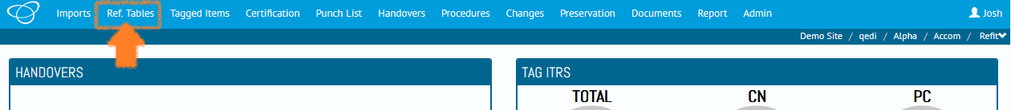

If you have a look, you’ll see there’s quite a lot of them, however we don’t need to populate them all at the same time (or ever if they’re not required!) only the ones that we know, or that we need to move forward and set up the more complex entities.

As an example, let’s look at what Reference Tables we need to add our first Tag.

Tags have a lot of fields, but only a few of them are **Required**.

**Required Fields**

When a field is Required it means that it won’t be possible to add a new record if those fields are blank or contain invalid information (and hub2 will tell you if the information is invalid).

For Tags the standard required fields (as of the time of writing – things do change!) are:

* Name
* Discipline
* Description
* Equipment Type
* Subsystem

And of those, Name and Description are not Reference Tables. Remember, as we described in the UI chapter, we can tell which fields are Required, and which are Reference Tables just by looking at the fields themselves:

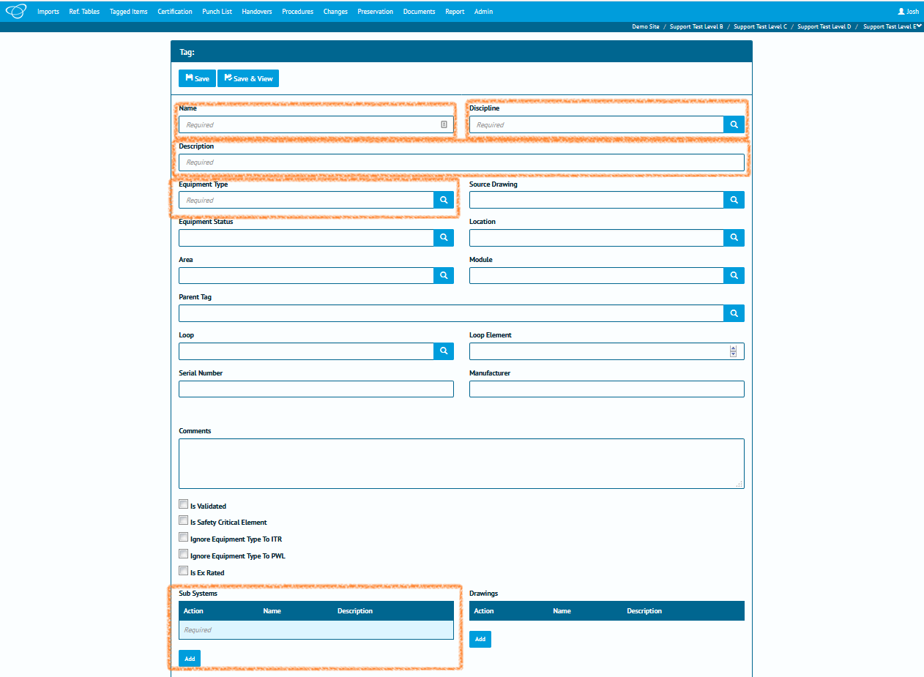

Required fields have the word “*Required”* inside the text box when they are empty:

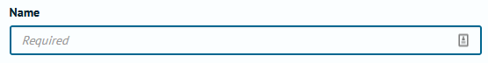

Reference Tables have a blue magnifying glass button at the right-hand side:

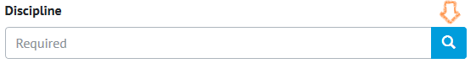

Clicking on this button will open a pop-up window, from which you can select the information you want, just by clicking on it:

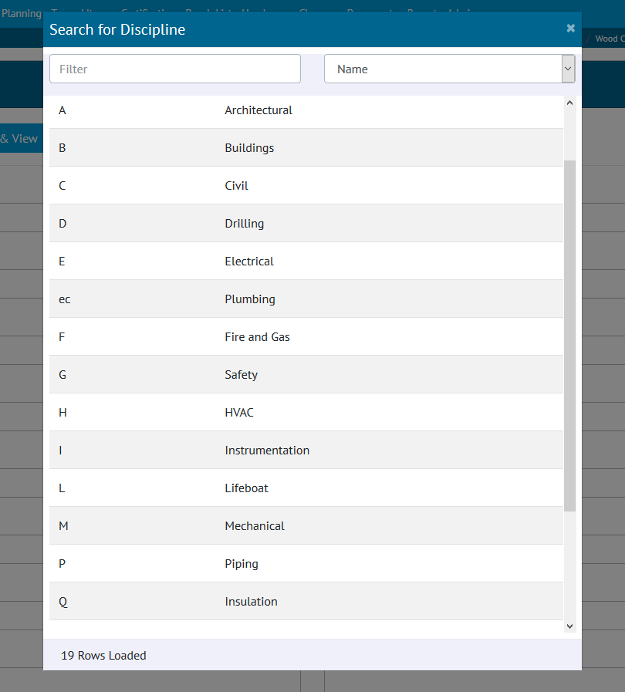

In some pop-up windows (such as Subsystems) you can choose multiple values. In that case you click on the rows you want **then** click the add button:

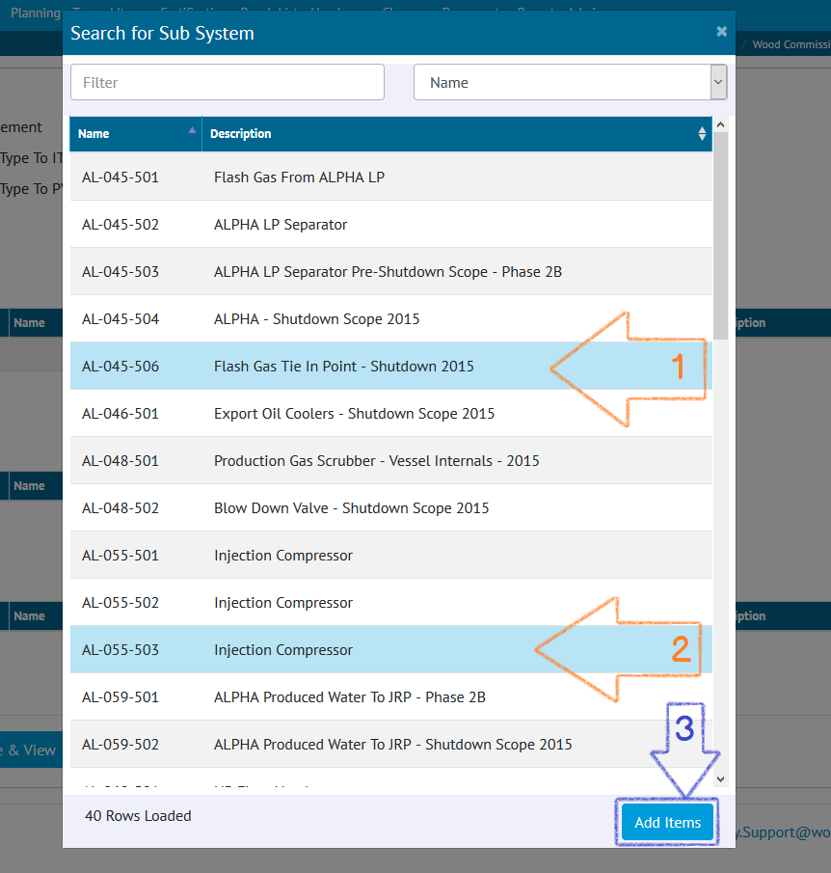

If the pop-up window is blank, that means there is no data in the reference table:

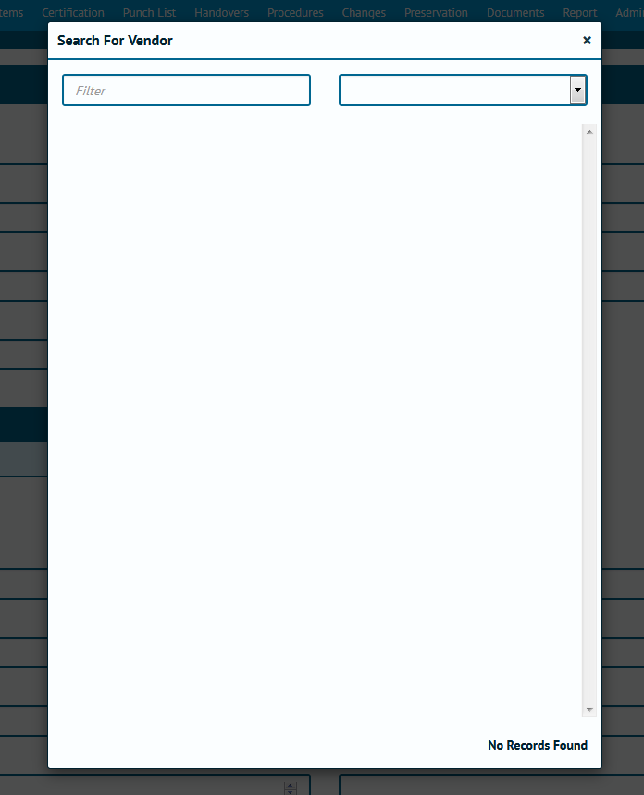

If that’s the case, (or we just want to add in an additional value) we know we need to go into the reference table and add some values in! Just click on Reference Tables and select the appropriate choice (for this example we’ll use Disciplines).

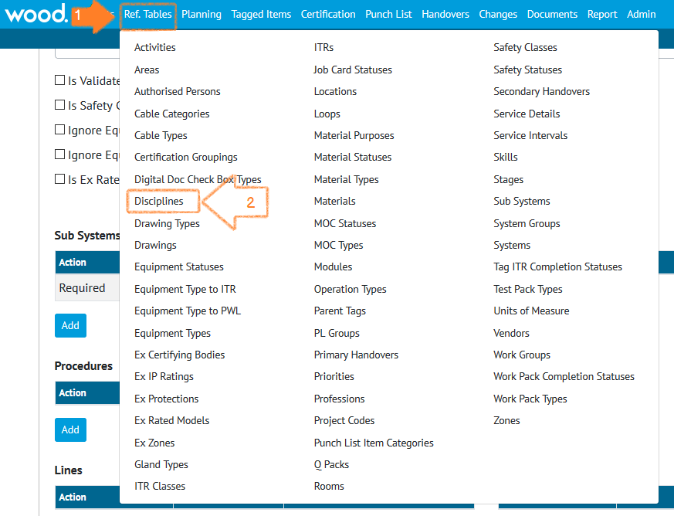

Help! I can’t see the table I want!

If the table you need to populate isn’t in the list then you might not have access to it. Talk to your GoTechnology focal point about it.

If you ***are*** the GoTechnology focal point then get in touch with us instead! We’ll help figure it out.

Once we’ve chosen the table we can go ahead and add data in (provided we have the right permissions).

If you can’t see an Add button then you need to get in touch with your focal point or with us to discuss.

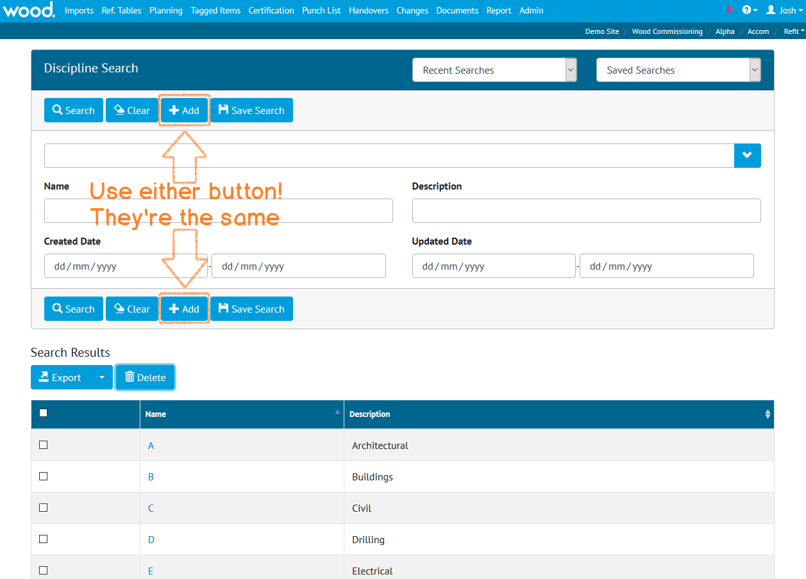

You can click either Add button, they both do the same thing. We have them at the top **and** bottom because some of the pages are quite long, and it makes it a little easier to use.

Enter in a name and description and click Save & View.

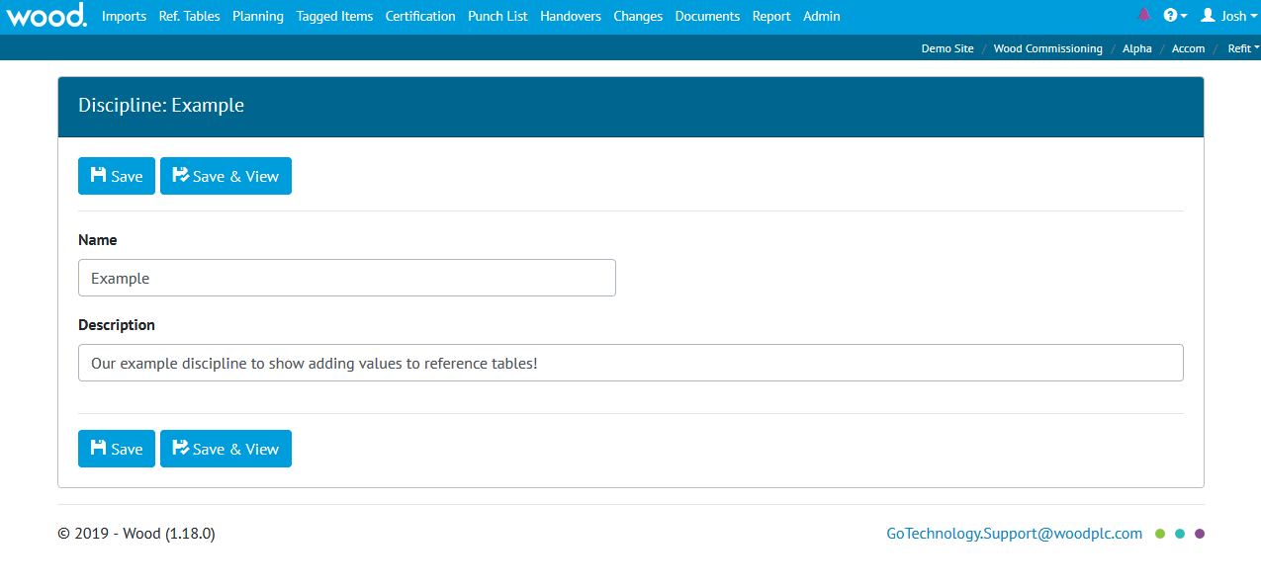

Now we can go ***back*** to Tags and when we are adding or editing and we click on the Discipline popup button we’ll see our new “Example” discipline in the list.

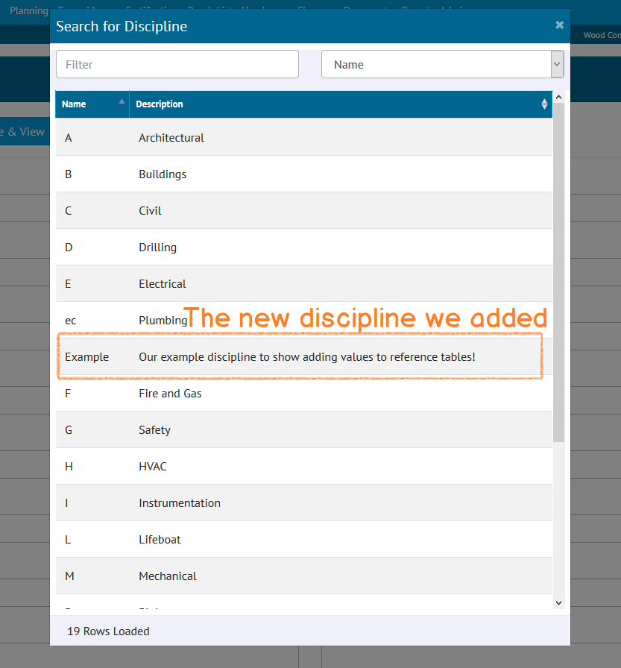

## Using Imports and Exports

By now you’re a totally confident GoTechnology expert. You’ve completed all the required training ***and*** you’ve read this far into the User Guide! Well done! That means you probably know all about the imports, and some of this might be repeating the obvious. But there might just be a few tips and tricks you’re not aware of.

### Downloading all blank templates

Let’s start at the beginning: Where do we go to get all the blank import templates? Simple: Go to Imports and click the “Download All Blank Templates” button:

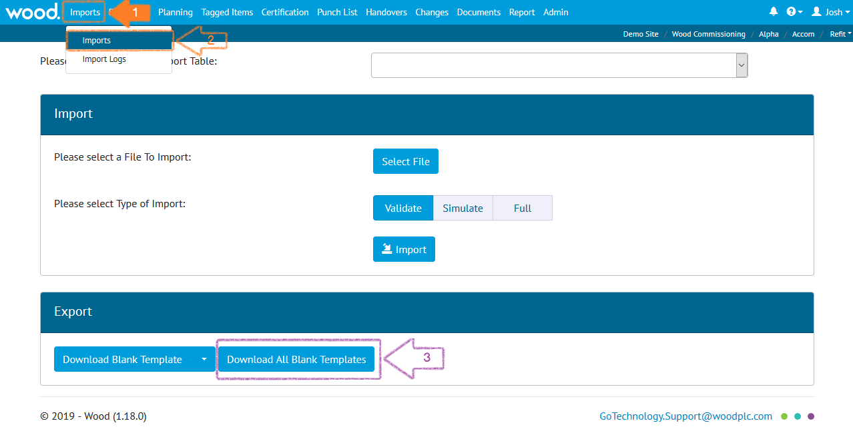

That will download a zipped file with all the blank templates ready to be populated.

### Import Templates

All the import templates for GoTechnology are simply spreadsheets and can be opened in Microsoft Excel or similar and they utilise coloured headings to convey information:

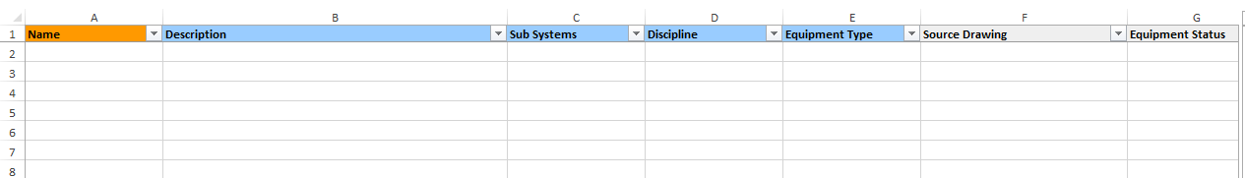

These colours are there to help you understand the nature of the fields. They’re only there to aid you, so changing them won’t make any difference.

But what do they mean?

|  |  |  |  |
| --- | --- | --- | --- |
| Heading Colour | Meaning | Can be removed? | Details |
| Orange | Identifying | No | Uniquely identifies the record. There may be more than one Identifying field, meaning the record is identified by the combination of multiple fields. |
| Gold | Optional Identifying | Sometimes | Can be used as part of the identification for the field but if not then can be removed. |
| Blue | Required | Sometimes | Must be populated when new records are created. For existing records this can be removed. |
| White | Optional | Yes | Can be removed. |

It might sound complicated but really, it’s not:

* When you’re creating new records, you need at least the Orange and Blue fields.
* When you’re updating existing records, you need at least the Orange fields.

That’s it!

Wait! What about the gold fields?!

A gold field is an **optional identifier**. That means they’re there to give you a way of differentiating two records that would otherwise seem identical.

Imagine it this way: Your name is John Smith and you’ve just joined a new company. Unfortunately, there’s already a John Smith there. As a way of telling the difference people might start using your middle name too. It’s an **optional identifier.** If there was only one John Smith it wouldn’t be required, but as there are two it’s useful to fill in.

This means that if we want to change an optional field such as Source Drawing **we can remove the columns we don’t need from the import sheet** leaving just the identifying column and the column we want to change:

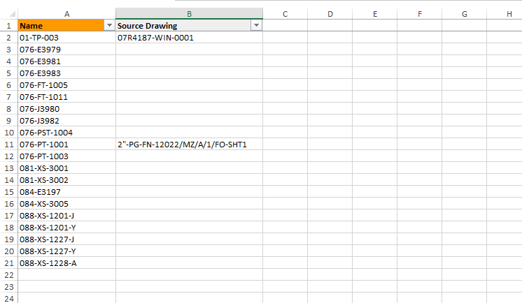

Not only does this make it easier to read, it’s faster to import too!

You can also change the order of the columns, so Source Drawing comes first and then Name.

Don’t try renaming the column names though; that won’t work.

### Import Types: Validate, Simulate and Full

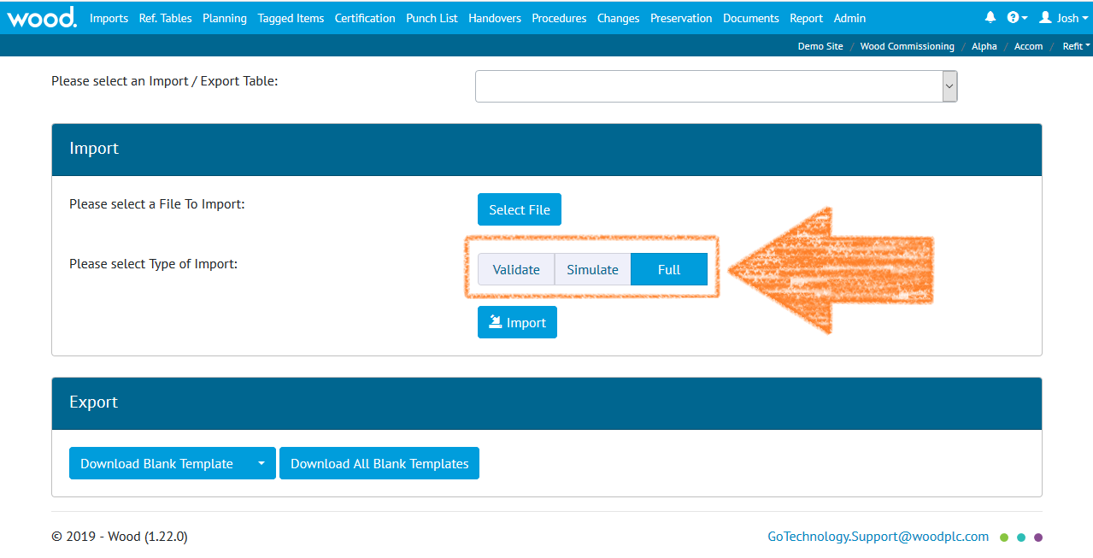

You might have noticed that there are three different options when running an import:

* **Full:** This is a standard import. Use this when you want to load the contents of the spreadsheet into the database. You get a results file at the end telling you what worked and what didn’t.
* **Simulate:** Use this when you want to perform a “**trial run**”. It acts like an import but it doesn’t actually change anything: You’ll get the results file telling you what *would* happen, **but the data isn’t actually loaded into the database**. Think of it like a “what-if?” analysis, letting you catch any issues ahead of time.
* **Validate:** This performs very limited, very basic checks: Is this a spreadsheet? Does it have headers that make sense? Are dates in the right format? Do any of the fields contain too many characters? The difference with this and Simulate are that validate does not check the database.

I don’t get the difference between Simulate and Validate!

**Simulate** performs everything **except** actually adding the data to the database, that means it checks the basic rules **and** whether the required information exists in the database. **Validate** only checks the basic rules.

That means if you try to assign a Tag to a Subsystem that doesn’t exist (let’s call it “ASubSystemThatHasNotBeenAdded”) a Validate import will say that’s OK: The name of the Subsystem is less than 50 characters.

On the other hand, if you ran a “Simulate” (or Full) the results will say the record is invalid with the reason “ASubsystemThatDoesNotExist is not a valid Sub System”

**You don’t have to run Validate or Simulate. They’re just there to help you – if you feel confident you can run a Full Import straight away** *(although personally we always like to run a Simulate first… We’re the cautious type!)*

|  |  |  |  |
| --- | --- | --- | --- |
| Type | Basic Checks | Reference Checks | Adds Data to Database |
| Validate | Yes | No | No |
| Simulate | Yes | Yes | No |
| Full | Yes | Yes | Yes |

# Handovers

Handover Certificates, usually referred to simply as ‘Handovers’ are used to guarantee Technical Integrity when responsibility is being transferred between Authorities.

Exactly what is being handed over, and when, varies between company, project and geographic location. Because of this, GoTechnology applications have a flexible approach, with a variety of configurations which can be used on a “per-scope-of-work” basis (Level E within hub2) allowing each to have its own Handover configuration.

The key components in each Handover are:

1. Name
2. Grouping
3. Gating

While the name is self-explanatory, the Grouping and Gating require further explanation.

### Grouping

The Handover Grouping controls the “what” of the Handover, as in “What is it that I am handing over?” Perhaps the most commonly used Handover Groupings are System and Subsystem (e.g. when a Subsystem Handover is completed it represents a statement that responsibility for that Subsystem can be transferred onwards) but there are other categories too. The following groupings are available in hub2

1. Certification Grouping
2. System
3. Subsystem
4. Primary Handover
5. Secondary Handover
6. System / Discipline
7. Subsystem / Discipline
8. Area
9. Module
10. Level E

### Gating

The Handover Gating determines the “which” (the ‘scope’) and “when” (the ‘ordering’) of the Handover within the overall project, serving to answer the questions “Which certificates/ITRs are covered by this Handover and when in the complete Handover process should this particular Handover occur?”

Both questions are answered with a single field: The Handover Gate Number.

This field acts as both a link between the Handover and the ITR Classes as well as means of ordering the Handover within the project.

#### Example: How Gating affects ordering.

As an example of how this works, consider a scenario where there are three Handovers (please note these are intended as examples only):

|  |  |
| --- | --- |
| Handover | Gating |
| HOC | 3 |
| MCDAC | 1 |
| PCDAC | 2 |

The Handovers are listed above alphabetically; however, in terms of the order within the Process, the MCDAC comes first, followed by the PCDAC and finally the HOC.

We can expand this further with an additional Handover:

|  |  |
| --- | --- |
| Handover | Gating |
| CCC | 1 |
| HOC | 3 |
| MCDAC | 1 |
| PCDAC | 2 |

Now we can see that both the CCC and the MCDAC are to be completed first, followed by the PCDAC and HOC.

#### Example: How Gating affects scoping.

If we retain our previous set of four Handovers and introduce a table listing our ITRs and ITR Classes we can see how Gating affects scoping too.

|  |  |
| --- | --- |
| ITR Class | Gating |
| COM | 3 |
| MC | 1 |
| PC | 2 |

Now we know that our CCC and MCDAC cover all ITRs in the MC ITR Class, our PCDAC covers all in the PC class and our CCC in the COM class.

### Walk Downs

Another key element in the handover process involves the physical inspection of the scope of the Handover (be it a System, Subsystem, Area or something else) by the process stakeholders. This process is known as a Walk Down.

There may be multiple Walk Downs held but all have the same general purpose: To identify any unrecorded defects and to verify that defects which have previously been identified have been actioned appropriately.

# Preservation

Preservation involves tasks related to ensuring unused equipment is kept in working condition. These tasks are often repeated on a regular schedule, to ensure the equipment is properly maintained and ready to use when required.

### Preservation Work List (PWL)

Within hub2 ‘Preservation Work Lists’ (PWLs) are used to record the completion of preservation tasks, and can be assigned to Tags, in a similar fashion to ITRs. The difference is that PWLs are part of a regular schedule of maintenance on unused equipment, while ITRs are used to sign-off that installed equipment is safe and has been properly tested as part of the Handover process (in which the goal is to start, or restart, the facility).

### Tag Preservation Work List (Tag PWL)

Just as a Tag ITR represents an actual assignment of an ITR to a Tag so does a Tag PWL represent a PWL to a Tag. To explain this further; our PWL table will contain an entry for each type of Work List available for use. So, if there are ten different Work List types (perhaps named ‘PRES-A’, ‘PRES-B’,’PRES-C’ and so on) then there will be ten entries in the PWL table.

However, any one of these PWLs may be assigned multiple times to many different tags. This is where the Tag PWL entity comes into play; storing the details of each Work List the user creates and assigns.

### Frequency

The Frequency of a Tag PWL describes how regularly the applicable preservation work should be performed. If a Tag PWL has a Frequency of seven days, then it should be performed once every week.

If it has a Frequency of 365 days it should be performed once, and then is not due for another 365 days, either from the Due Date (so the schedule remains consistent) or from the Sign-Off Date (so the schedule adjusts based on when the Tag PWL was actually signed off), depending on the configuration of hub2.

### Due Date and Sign-Off Date

The Due Date is when the Tag PWL is expected to be completed by, while the Sign-Off Date is when the Tag PWL was actually signed off. It is possible in hub2 to apply restrictions to when Sign-Off can be accomplished, via the Level C Preservation Window Before and Preservation Window After settings.

### Preservation Window

The Preservation Window (via the Preservation Window Before and Preservation Window After fields on Level C) allows restrictions to be placed on when a Tag PWL can be signed-off, specifically in relation to the Due Date.

The settings allow the Preservation Window to be restrict how many days before and how many days after the Due Date is acceptable. These values can be different. If either (or both) value is left blank, then no restriction applies.

#### Examples

##### Due Date: 14 February 2017

|  |  |  |  |
| --- | --- | --- | --- |
| Due Date | Preservation Window | | Acceptable Sign-Off Values |
| **Before** | **After** |
| 14 February 2017 |  |  | Any |
| 14 February 2017 |  | 2 | Any date **before** 17 February 2017. |
| 14 February 2017 | 2 | 2 | 12 February 2017 to 16 February 2017. |
| 14 February 2017 | 5 | 2 | 9 February 2017 to 16 February 2017. |

##### Due Date: 20 March 2049

|  |  |  |  |
| --- | --- | --- | --- |
| Due Date | Preservation Window | | Acceptable Sign-Off Values |
| **Before** | **After** |
| 20 March 2049 |  |  | Any |
| 20 March 2049 |  | 2 | Any date **before** 19 March 2049. |
| 20 March 2049 | 3 | 4 | 17 March 2049 to 24 March 2049 |
| 20 March 2049 | 31 | 16 | 17 February 2049 to 5 April 2049 |

### Preservation Progress Method

Preservation Progress Method is a Level C setting which will be used to determine the next Due Date when advancing Preservation which is being signed off. When any Tag PWL item which has a populated Frequency, field is signed off a new Tag PWL record will be created and its Due Date will be set based on the Preservation Progress Method as detailed in the following table:

|  |  |  |  |
| --- | --- | --- | --- |
| Preservation Progress Method | Due Date | Sign Off Date | Advanced Due Date (Frequency of 5 Days) |
| Due Date | 15/01/2016 | 18/01/2016 | 20/01/2016 |
| Sign Off Date | 15/01/2016 | 18/01/2016 | 23/01/2016 |

# Assurance

The Assurance section is as an area where project related lists can be recorded. It is intended to provide users with an alternative to the use of uncontrolled spreadsheets stored on network drives or emailed between recipients and may be beneficial for scenarios such as

* Pre-Construction Trackers
* Operation Readiness Trackers
* Competency Recording

## Creating a Tracker

Before an Assurance Tracker can be created, we have to first create a Tracker Type. We can do this through the Tracker Type import or on-screen via Ref. Tables > Tracker Types

### Creating a Tracker Type

The type of Tracker we wish to create is a “Statement of Fitness”. Normally it is an Excel spreadsheet:

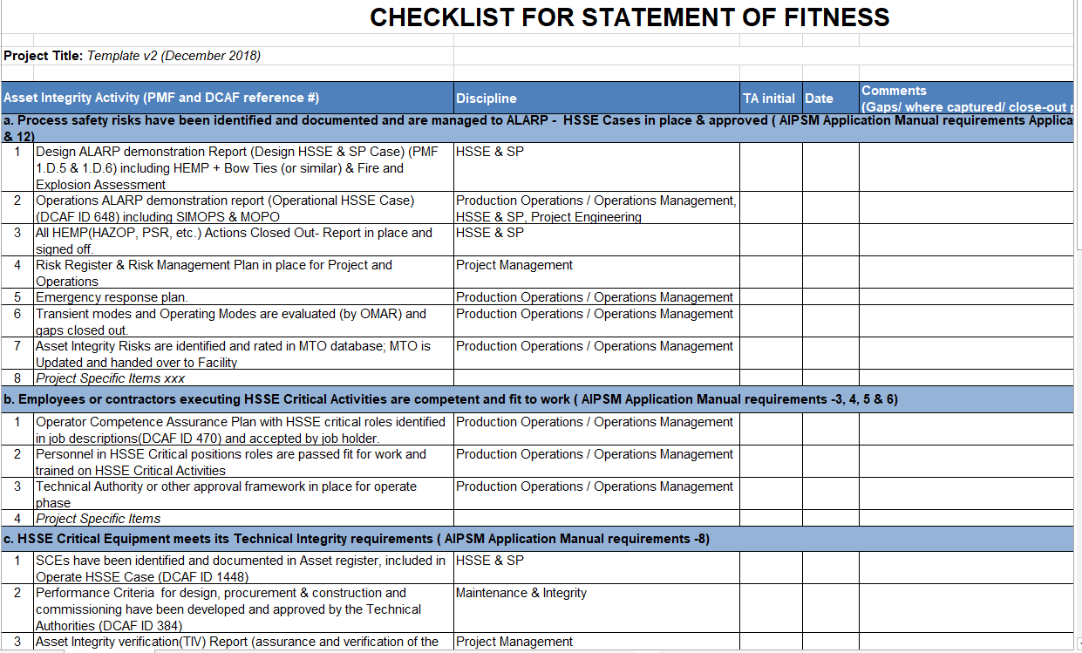

We want to convert it to be stored in GoTechnology hub2 instead. Firstly we create the Tracker Type: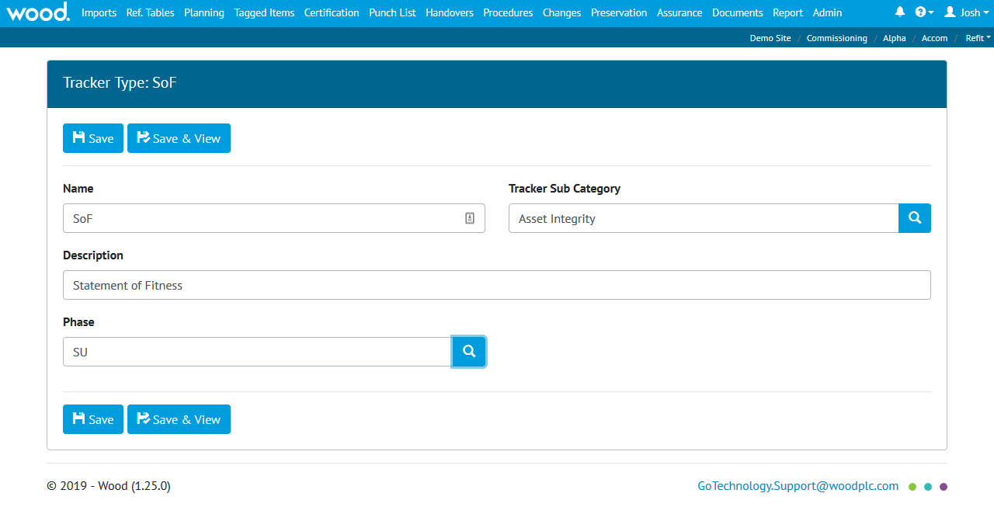

Aside from the name and description (“SoF” and “Statement of Fitness” respectively) we’ve chosen a Sub Category of Asset Integrity and a Phase of SU (Start-Up).

The Sub Category (and it’s parent Category) are user-defined references tables, which you can use to create groupings. The values are up to you/your company/your focal point – for this example we have a Sub Category of “Asset Integrity” (as that is what the SoF applies to) which belongs to a Category called “Mandatory Forms” (as organisations that use an SoF make it a required part of the project execution)

**Note: Phase and Sub Category are optional, but if you do wish to use them, you’ll need to ensure the following tables have been populated in advance:**

* **Tracker Category**
* **Tracker Sub Category**
* **Phase**

Once we’ve saved this information (click “Save & View”) we can move on to creating the template itself.

### Creating the template

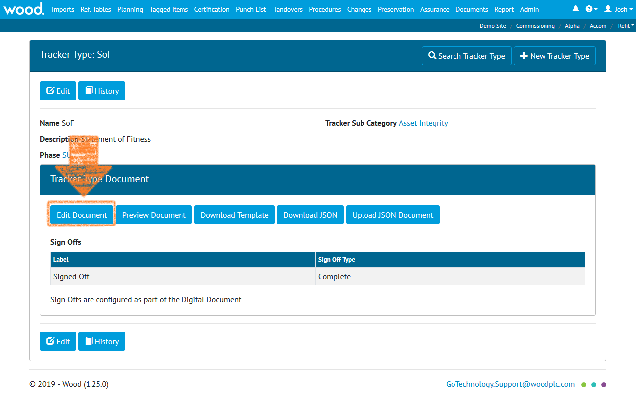

By clicking the Create/Edit button we can begin the process of setting up our SoF Tracker Type Digital Document.

The process is the same as with other types of Digital Document, such as ITRs and Work Pack close out forms, and involves defining any bookmarked header fields, the tasks to be completed and the sign-offs required.

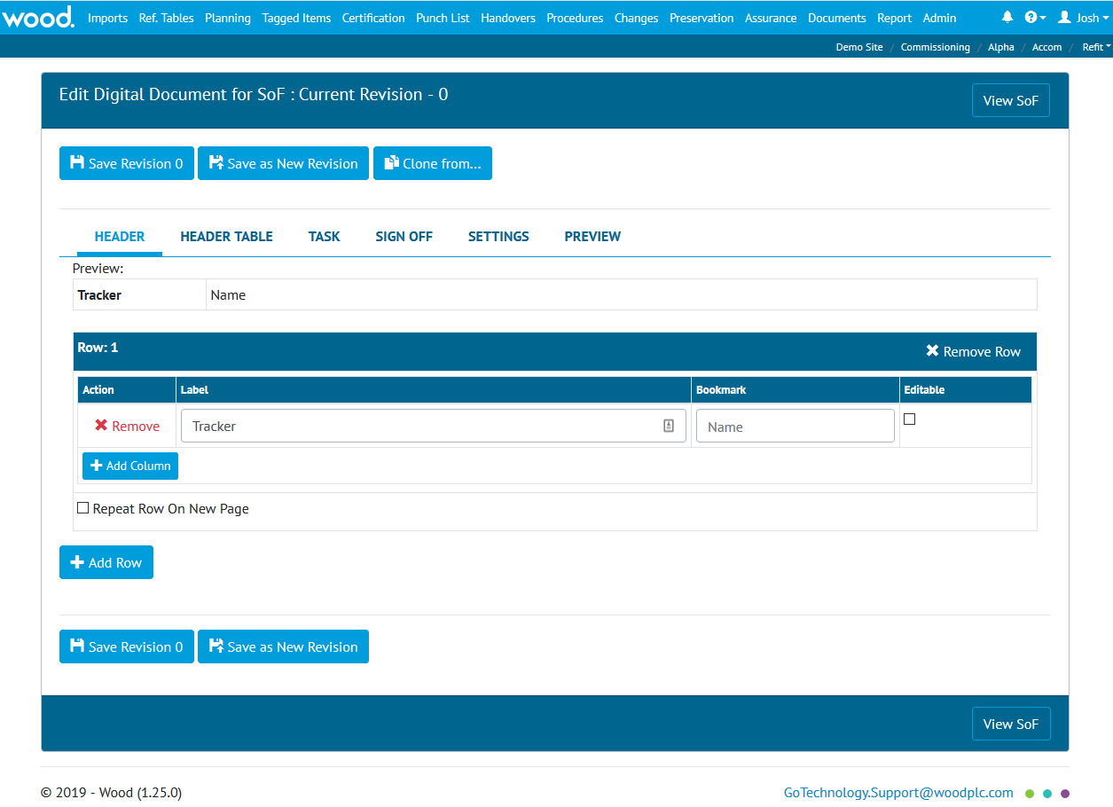

Our SoF template only has a single header value: Name.

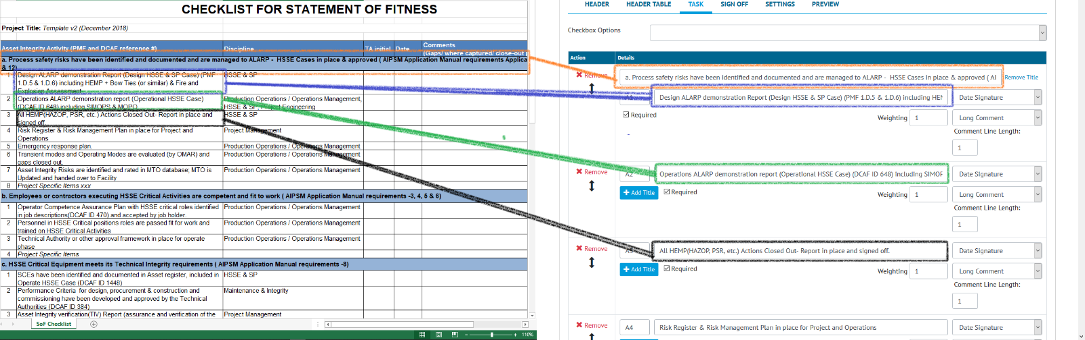

Next we copy the information from the existing spreadsheet into the Digital Document Tasks

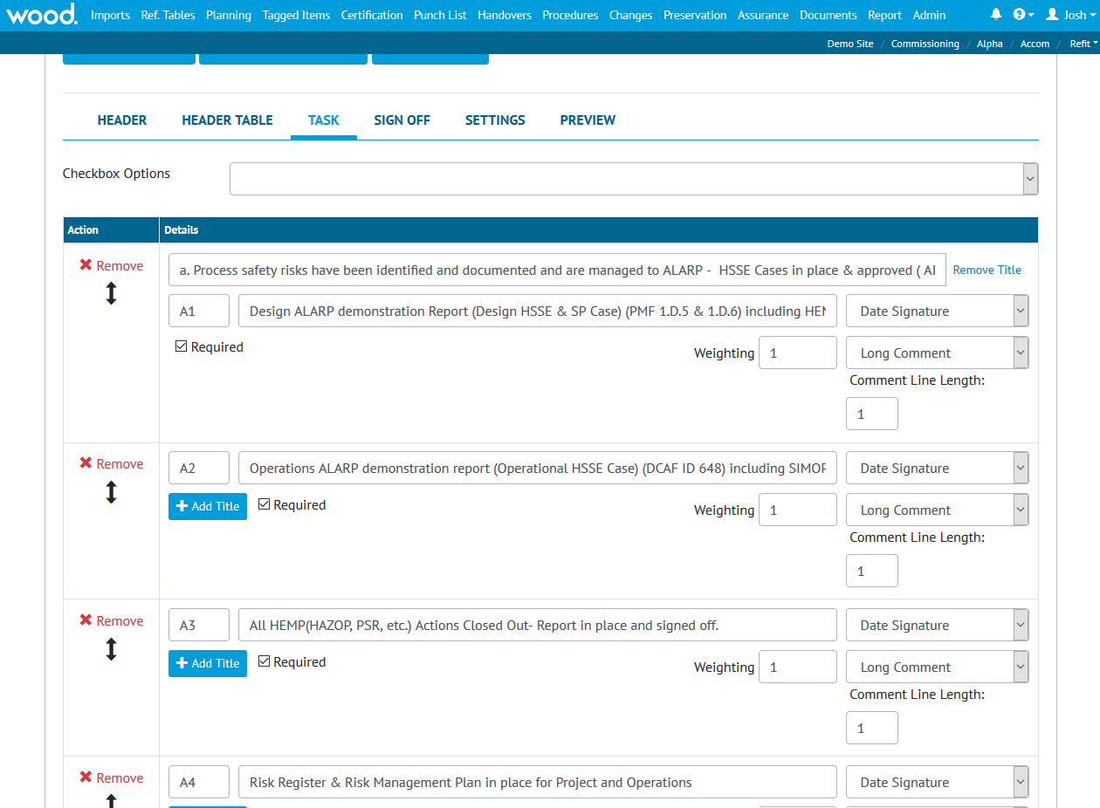

Once we’ve finished copying the Tasks over, we can move on to adding the Sign-Offs.

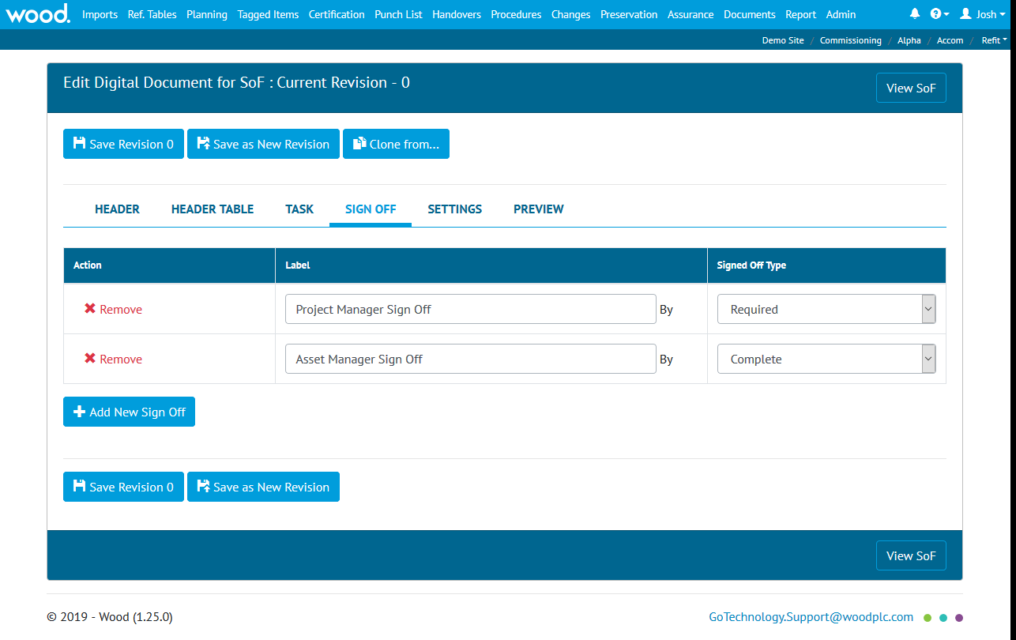

The SoF has two: Project Manager Sign Off and Asset Manager Sign Off, both are mandatory but it is the latter which marks the SoF as closed and accepted, so the types are “Required” and “Complete” respectively.

Our template is now complete and can be used by projects. We’ll only need to revisit this section if we wish to make changes to the template.

### Creating and Filling in an Assurance Tracker

Now we have the SoF tracker type created, we can proceed to the Assurance > Assurance Tracker type to use the template.

Go to Assurance > Assurance Tracker and click the “Add” button, that will bring up the creation screen:

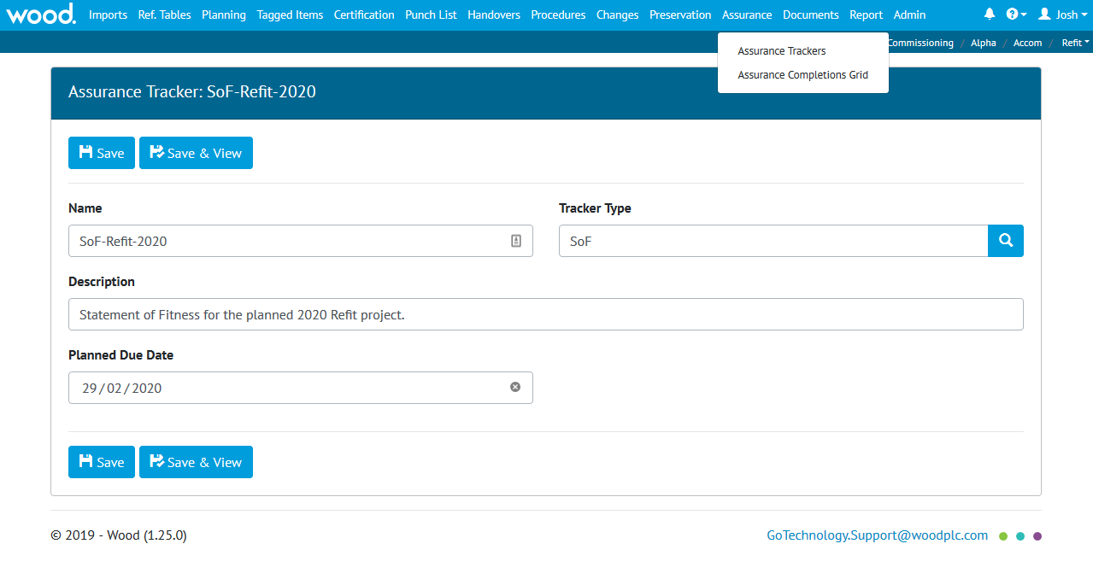

We’ve given our SoF a name (this will be shown on the header of the document, as we bookmarked this field during the process of creating the template in the Tracker Type) and description as well as a planned due date. We also chose the correct Tracker Type of “SoF” in the Tracker Type field.

Click Save and View

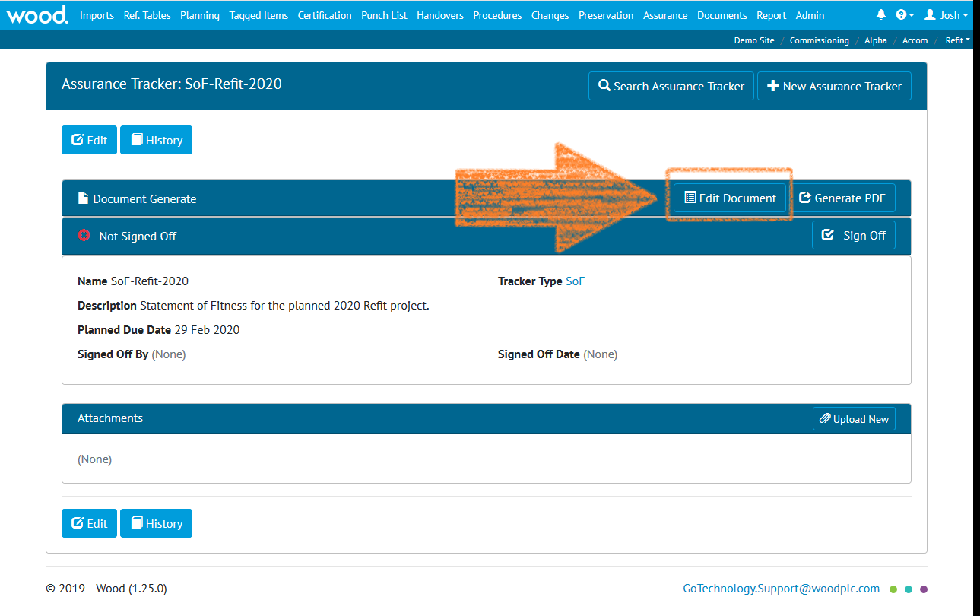

Then click “Edit Document”

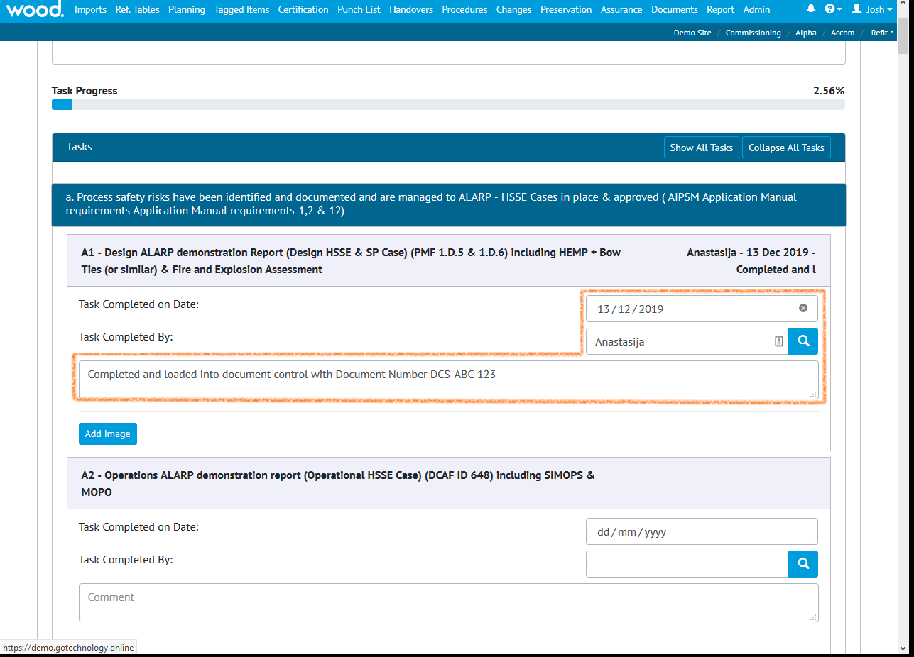

Now we can fill the Tracker with the results and save them by clicking the “Save” button.

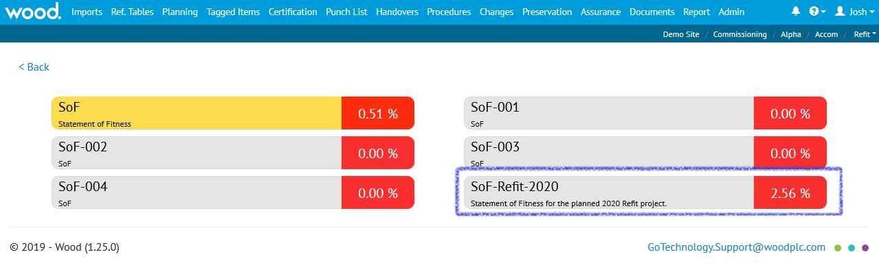

Finally, by going to Assurance > Tracker Completion Grid we can see a visual representation of our progress. 2.56% - it’s not much but it’s a start!

# Reports

Now you’ve loaded all your data (or at least the first batch) you probably want to know how to use it to generate status and progress reports. Well, GoTechnology hub2 has several options at your disposal.

## Dashboard

The first and most visible report you’ll see is the Dashboard. It acts as an overview and a “health check” of the Scope (Level E) you’re currently viewing:

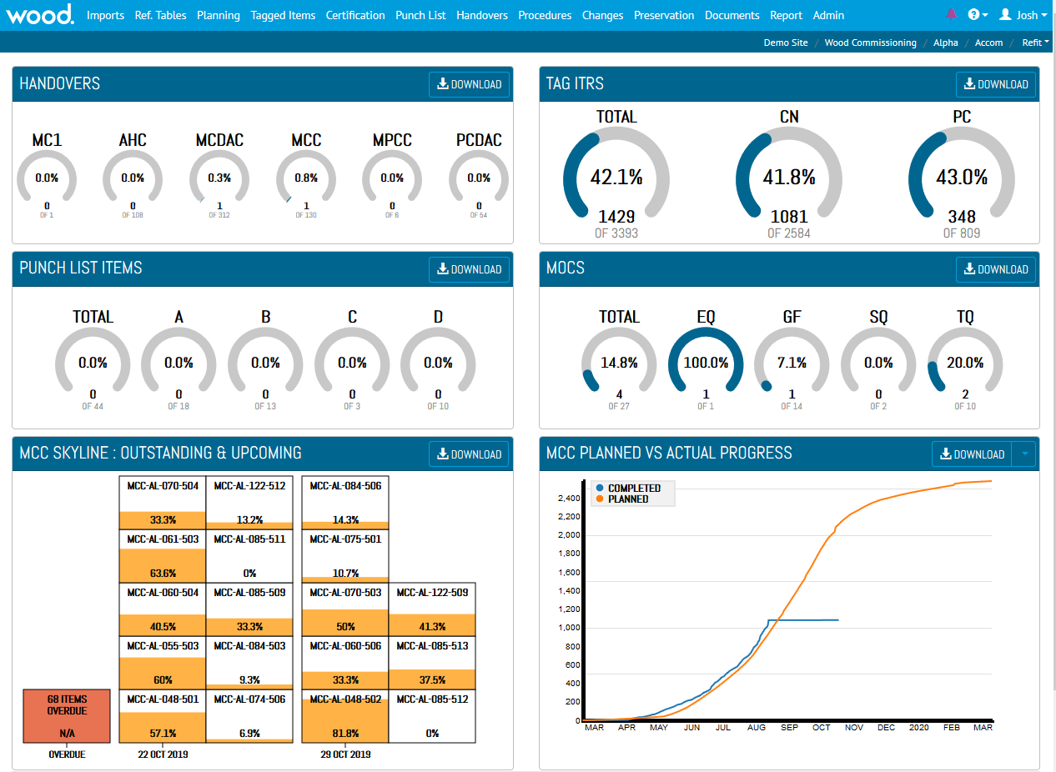

The dashboard is divided into six sections, which we’ll detail below.

### Handovers

This section shows up to six types of Handover. They’re listed by “gate” and then alphabetically. Each dial shows a percentage of how many Handovers of that type have been signed off as Complete.

### Tag ITRs

The first dial here shows the total percentage of ITRs signed off. After that it’s broken down by ITR Class. Up to five different classes can be shown at once (remember; you set up your ITR classes in the reference tables), and they’re ordered in the same way as the Handovers (gate then alphabetical)

### Punch List Items

Similarly, the Punch List dials show the total and then the Punch List categories (as defined in your Punch List Categories reference table). They’re listed alphabetically.

### MOCs

MOCs follow the same pattern – overall total and then a total for each MOC Type. Once again, the total represents the number of MOCs that are closed.

### Mini-Skyline

Here we have a cut-down version of the Interactive Skyline (which you can find in Reports > Skyline. There’s also Filtered Skylines in Reports > Report List at the bottom of the page) which is fixed to only show one type of Handover (in the screenshot above it’s MCC, which is a Mechanical Completion Certificate). If you’re an Administrator you can choose which Handover is displayed on the dashboard in the Level E configuration screen.

Skylines show a left-to-right view of a project. Each box represents a Handover, and **they’re grouped together by the date they are due** (the Planned Finish Date for the Handover. You can set this value in the Handovers section, or via the Handovers imports)

|  |  |
| --- | --- |
| Foreground Colour | Meaning |
| Orange: | Progress is being made! |
| Green: | All the ITRs are complete!! |
| Blue: | The Handovers been accepted!!! |

|  |  |
| --- | --- |
| Background Colour | Meaning |
| White: | We haven’t passed the Planned Finish Date for this Handover (and we’re 50% through the work on the ITRs) |
| Red: | Unfortunately, we’re now passed the Planned Finish Date for the Handover, which means we’re running behind schedule (and we’re 50% through the work on the ITRs). |
| Rainbows and Polka Dots | I just made this one up to see if you were still paying attention. |

On the mini-skyline, space is limited, so all the Overdue items are grouped together in one column.

Why are they called Skylines anyway?

Well, think of New York. The Big Apple. NYC. Picture those sky scrapers. That iconic ***skyline.***

Get the picture?

**New York Not New York**

 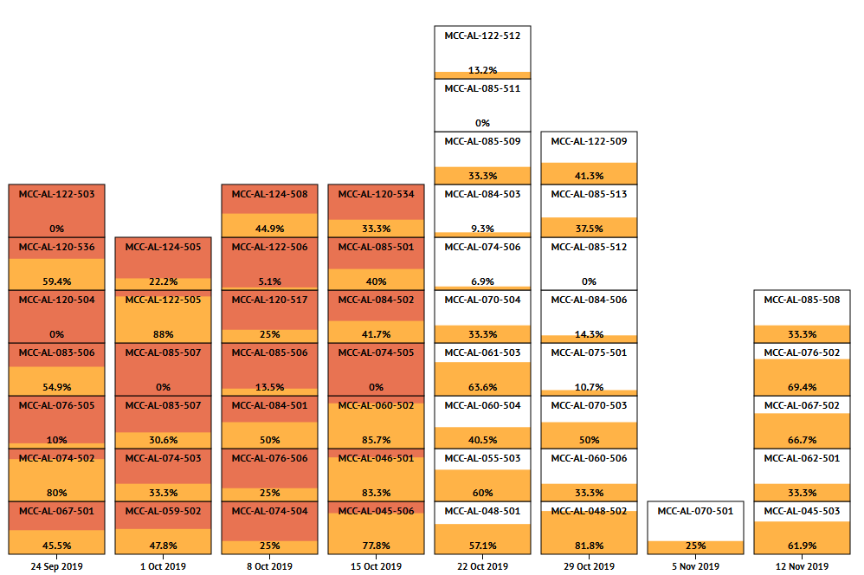

### Mini-Planned vs Actual

A smaller version of the Planned vs Actual report (the full version is available in Reports > Planned vs Actual) which is fixed to only show one type of Handover (in the screenshot above it’s MCC, which is a Mechanical Completion Certificate). If you’re an Administrator you can choose which Handover is displayed on the dashboard in the Level E configuration screen.

The Planned vs Actual reports show the total ITR Completion over time. As such, it’s actually the same information as shown in the Skyline, but instead of being broken down into individual Handovers, it’s totalled up and displayed in an “S-Curve” format.

## Completions Grids

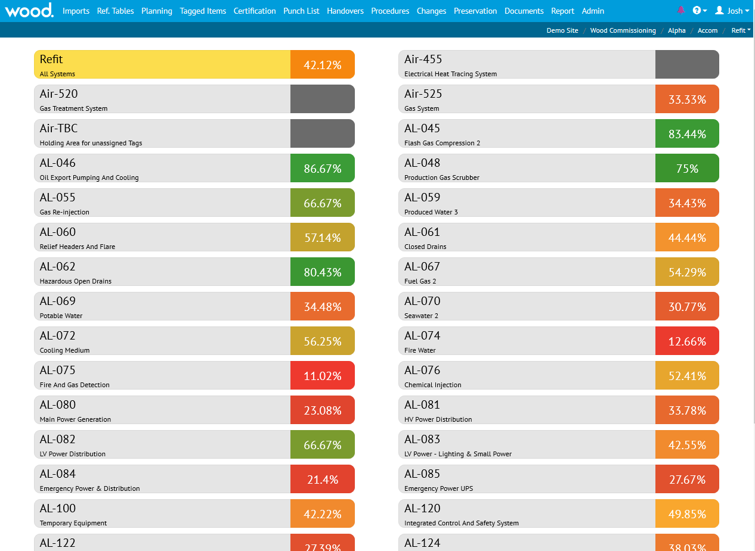

The Completions Grids provide an interactive visual view of the data, which can be a helpful way to quickly drill down into project Status.

### System

In the standard Completions Grid (Reports > Completions Grid) we get a listing of ITR progress by System. If we click on the System we get to the Subsystems, and if we click on the Subsystems, we get to the details page.

### Work Pack

In the Work Pack Completions Grid (Reports > Work Pack Completions Grid) we have a list of Work Packs. Clicking on a Work Pack gives us the Job Cards underneath and clicking on the Job Card gives us it’s details.

## Skylines

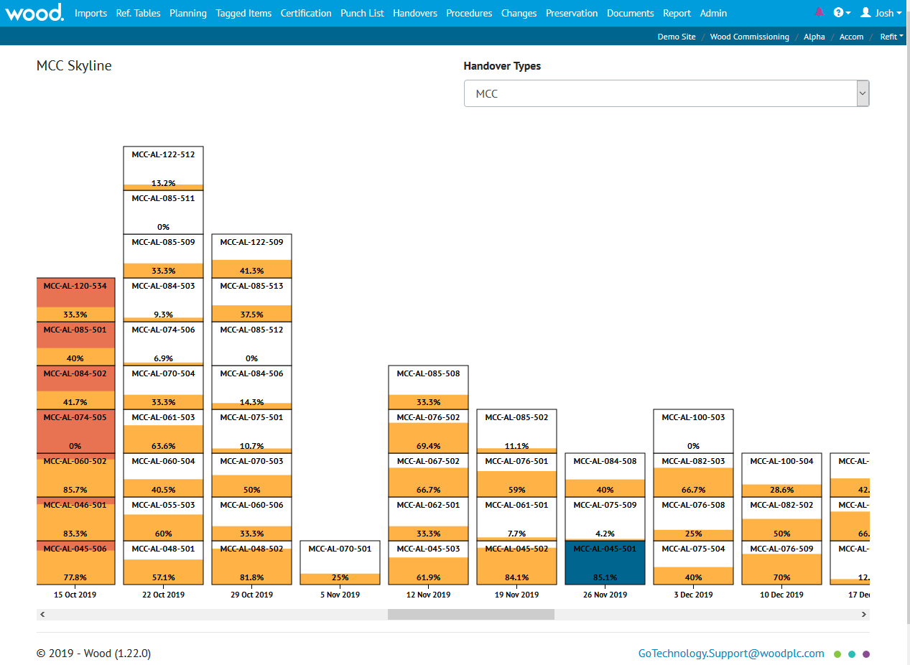

How do you like your Skylines; Interactive or Filtered? We’ve got both!

*(If you’d like to know what Skylines are, go back up to the Mini-Skylines section. We’ll wait here for you.)*

### Interactive

The Interactive Skyline is found in Reports > Skyline. You can choose the Handover Type from the dropdown, scroll left and right, and click on the box to bring up further details!

### Filtered

The Filtered Skylines are found in Reports > Report List at the bottom of the page. There’s one for each Handover Type.

What makes them filtered? Well, you can apply filters to them before you hit the run button, allowing you to narrow down the results to only include what you need.

Wait, what did you say was the difference between “Interactive” and “Filtered” Skylines?

**Interactive Skylines** are shown on screen. You can click on the boxes and more details come up on screen.

**Filtered Skylines** generate out as PDF files. Before you run them you can apply Filters like the Planned Start / Finish dates. This lets you target your results more specifically.

## Planned vs Actual

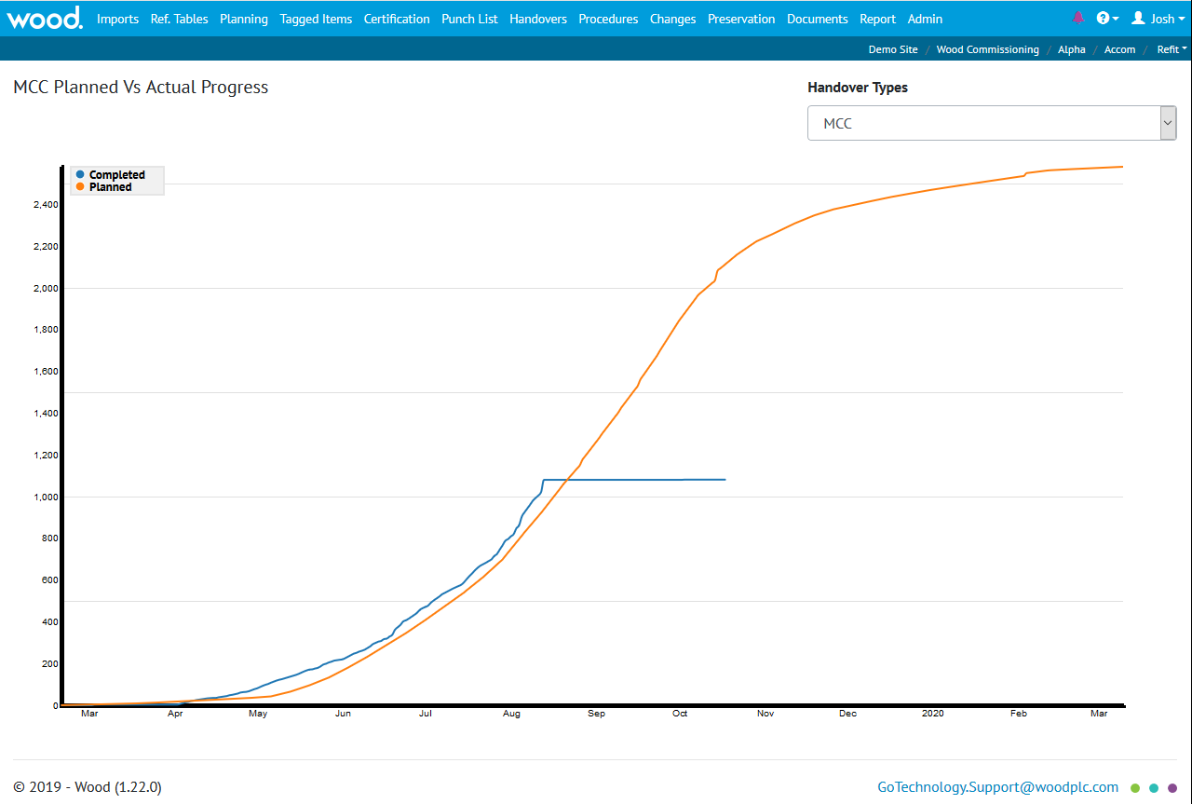

The full version of the Planned vs Actual report, available in Reports > Planned vs Actual Progress. You can choose which Handover to display using the drop down on the top right.

*(For more information on Planned vs Actual reports, please read the “Mini-Planned vs Actual” section earlier in the document.)*

Planned Progress is shown in Orange and Completed (Actual) in blue. From the looks of the screenshot above, someone will be losing their job soon!

## Detailed & Summary Reports

In GoTechnology hub2 **you** create the reports (provided you have the right permissions of course)

Let’s create one right now (or if you’d rather not, you can just skip this section. We won’t be offended.)

### Recreating the Detailed Filtered Report

The Detailed Filtered Report was far and away the most popular report in our old software GoCompletions (in fact 46% of the time people ran a report it was the DFR, making it more than three times as popular as the second placed Detailed Punch List report.)

To recreate it, just follow these steps:

Click Reports > Create Detailed Report

In the Type Dropdown choose “Tag ITR” 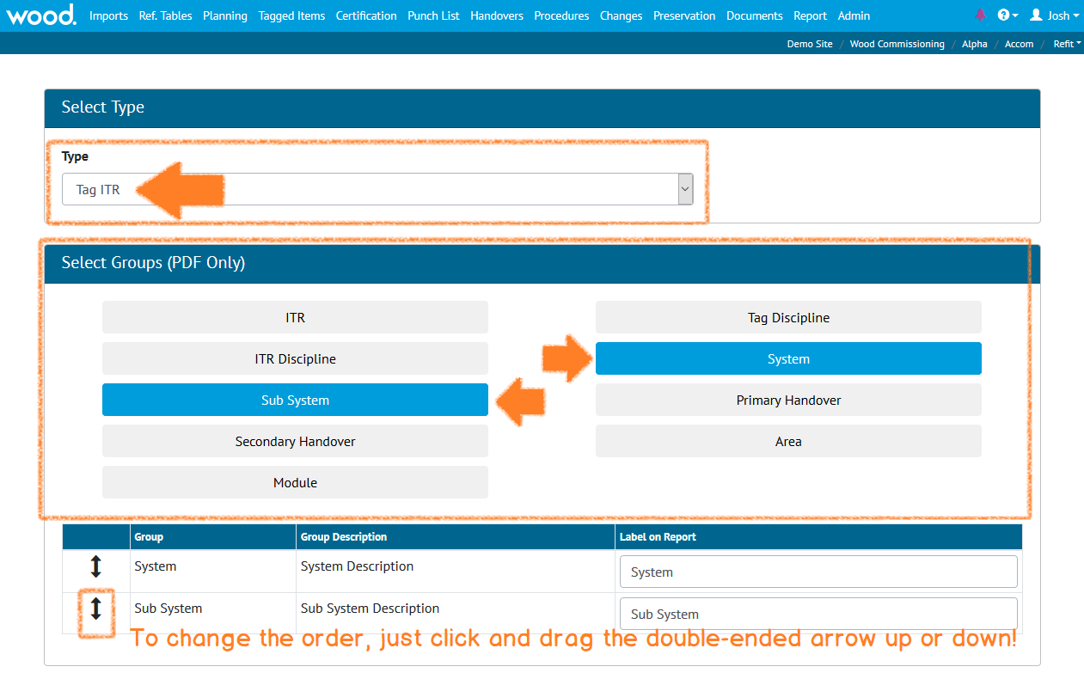

In the Select Groups section choose System and Subsystem, as shown **above**.

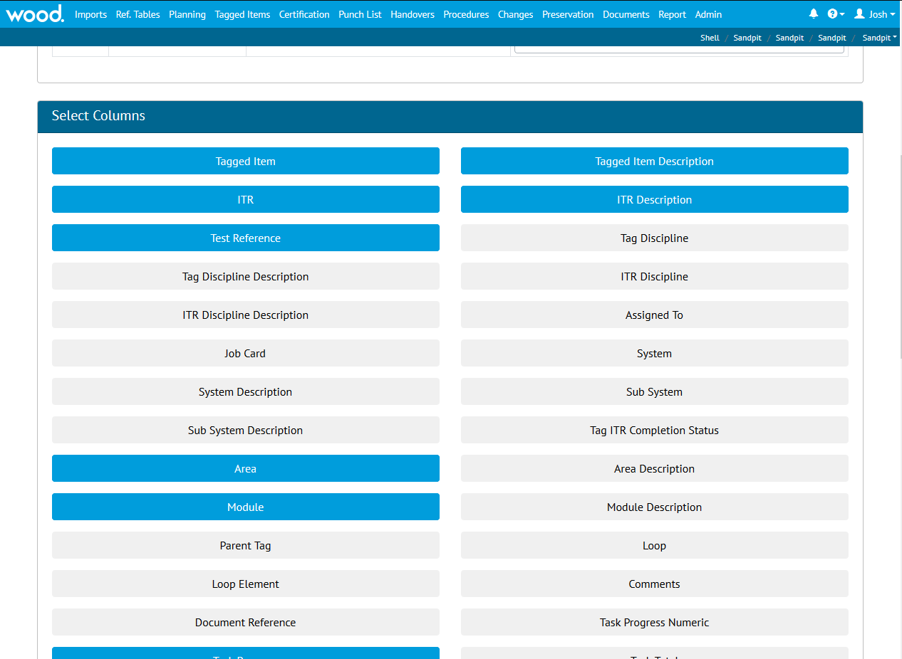

Scroll down the page and select the following fields (also shown **above**):

Tagged Item

Tagged Item Description

ITR

ITR Description

Test Reference

Area

Module

Completed By (this field may be called something different in your version, as the field can be renamed to match company specific terminology. If in doubt, ask your focal point!)

Completed Date

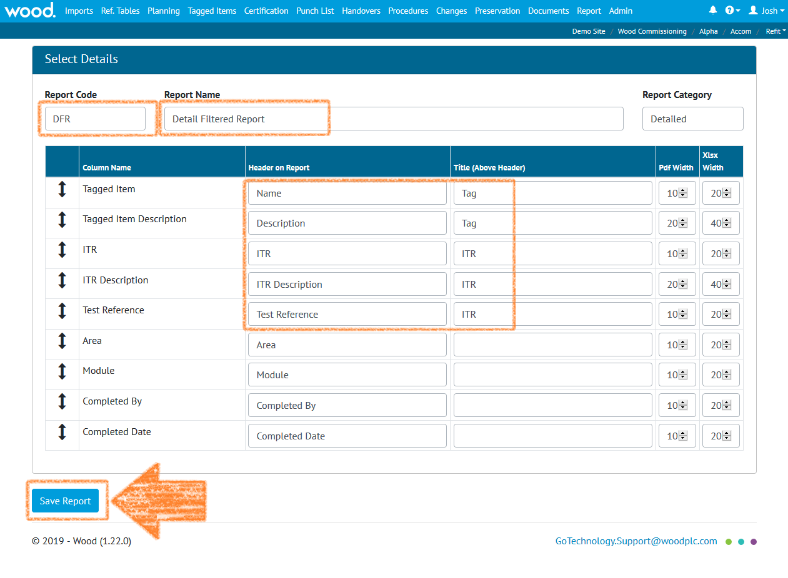

Now fill in the remaining fields (see screenshot below)

In Report Code enter “DFR”, this is just a short-hand way to refer to the report. Much easier to say.

Report Name, erase the text in there and replace with “Detail Filtered Report”. This is the full name – helpful in understanding what the report actually does.

For Tagged Item

Change the Header on Report to “Name”

Change Title (Above Header) to “Tag”

Similarly, for Tagged Item Description

For Header on Report use “Description”

For Title (Above Header) use “Tag” again. This will group the two together, which you’ll see later.

For ITR, change the Title (Above Header) to “ITR”

For ITR Description

Change the Header to “Description”

Enter “ITR” in the Title (Above Header)

For Test Reference

Rename to Test Ref

Enter “ITR” in the Title

Click “Save Report” and you’re done!

Remember: If any of the fields are in the wrong order, just click and drag the double ended arrow.

*You can also change the widths of the columns if you like – “PDF Width” affects how wide (or narrow) the columns are when you generate as a PDF. “XLSX Width” when you generate as a spreadsheet.*

Now use the top menu to go back to the Report > Report List page and find your report in the Detailed Category. Click on it (**DFR. Detail Filtered Report**), and then click the **Run PDF** button, you should get a PDF that looks a little like the below:

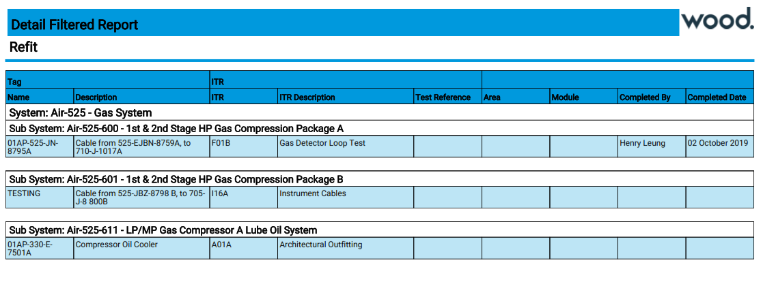

Well done! Now go make some more reports!

How do I edit my reports?

Go to Report > Report List and click the “Edit Reports” button.

Now just click the “Edit” button next to the report you want to change, and you’ll be back to the edit screen – and remember to click Save Report when you’re done!

# What order do I load the data in?

## Recommendations

It’s recommended that Imports are kept at 20,000 rows or less per file for performance reasons.

## Ordering

The recommended order to perform Imports is listed below. Those which are **essential** are **bold and underlined**.

### List

1. Primary Handover (if applicable)
2. Secondary Handover (if applicable)
3. Location
4. Module
5. Area
6. Priority
7. System Group
8. **System**
9. **Subsystem**
10. Loop
11. Activity
12. Unit of Measure
13. Test Pack Type
14. **Discipline**
15. Profession
16. Authorised Person
17. DrawingType
18. MOC Type
19. Operation Type
20. **Punch List Item Category**
21. Certification Grouping
22. **ITR Class**
23. **ITR**
24. Q Pack (if applicable)
25. PWL
26. **Equipment Type**
27. Equipment Status
28. Equipment Type to ITR
29. Drawing
30. Parent Tag
31. Tag ITR Completion Status
32. Preservation Completion Status
33. Work Pack Completion Status
34. **Tag**
35. **Tag ITR**
36. Tag Q-Pack
37. Tag Subsystem
38. Test Pack
39. Work Pack
40. Job Card
41. Operation
42. Procedure
43. Procedure System
44. Procedure Section
45. Procedure Skeleton
46. Procedure Skeleton Section
47. Procedure Skeleton Step
48. Procedure Step
49. Punch List
50. Punch List Item
51. Handovers (multiple)
52. Equipment Type to PWL
53. Tag PWL
54. Line
55. Spool
56. Mechanical Joint
57. Cable
58. MOC
59. MOC Discipline
60. MOC Primary Handover
61. MOC Secondary Handover
62. MOC System
63. MOC Subsystem
64. MOC Tag
65. MOC Work Pack

# Glossary / Listing

|  |  |  |  |
| --- | --- | --- | --- |
| Name | Description | Menu Location | Level |
| Activity | Activity within hub2 represents Level 3 in the recommended Work Breakdown Structure and as such exists as the “parent” of Job Cards and as a “child” of Level E.  The term “Activity” is often used interchangeably with Work Pack or Work Package, however hub2 treats them as separate but equivalent.  The Activity is intended to represent the Planning Component and as such represents a period of time utilised, rather than a physical collection of documents. | Reference Table | E |
| Area | Physical space, usually used in conjunction with Module representing part of a floor, an entire floor or even a whole building or structure, within a larger Asset or Facility. | Reference Table | C |
| As Built Drawings | As Built Drawings reflect what was constructed, rather than what was originally drawn; they are usually required when circumstances on site required a deviation and are issued when Construction is complete. | Documents | E |
| Attachment | An association between a file and a database entry. | Documents | C |
| Authorised Person | An entry in the Authorised Person reference table represents an individual who is authorised to perform certain activities on a work scope. Within hub2 Authorised Person is used to record information regarding the sign-off of a certification such as an ITR or PWL. Each one can be linked to a user account through the Hub User ID field. | Reference Tables | C |
| Cable | In simple terms Cables are collections of one or more lengths of electrically conductive materials that are contained within protective and non-conductive coatings. The coatings are commonly known as ‘Sheaths’. Each conductive-material-and-Sheath combination is known as a Core.  It is possible that a cable may contain only a single Core, however it is more likely that it will comprise multiple Cores contained within an additional overall Sheath. | Tagged Items | C |
| Certification Grouping | A means by which a collection of ITRs can be associated by Discipline, Subsystem and Level E, the Certification Grouping is an aliased entity (meaning the labels shown on page can be renamed from “Certification Grouping” to something else) that can be used to fill the role of a ‘Discipline Mechanical Completion (DMC)’ field, while allowing project specific naming of that field. | Reference Tables | E |
| Discipline | Perhaps the easiest way to begin to describe a Discipline is to provide some examples of it: Electrical, Mechanical, Safety, Fire & Gas. These represent not only schools of knowledge to which an individual might specialize in, or assume responsibility for, but also categories of equipment or certification.  Within hub2 the Discipline will be recorded against items such as tagged equipment (Tags), Punch List Items and Inspection and Test Records (ITRs). This can then be used to filter and subdivide information, as well as to assign permissions and responsibilities to authorised individuals, with the full details of these functions being detailed in the relevant sections. | Reference Tables | B |
| Drawings | Drawings can cover a range of different types of illustration, including Isometrics, Process and Instrumentation Diagrams and General Arrangement Drawings amongst others. They serve to communicate information visually in a variety of ways, with the type of drawing used determined both by convention and what is most effective for serving the purpose required. | Reference Tables | C |
| Equipment Type & Status | Equipment Type provides a way of categorizing Tags based on the type of equipment. This can be useful in determining what type of ITR should be assigned, something that is covered in more detail in the Auto Allocation of Data section.  Equipment Status represents a further subdivision of this, and is an optional attribute to enable greater granularity. | Reference Tables | C |
| Equipment Type to ITR / PWL | Allows ITRs and PWLs to be automatically assigned to a Tag based on its Equipment Type. | Reference Tables | C |
| Handover | Handover Certificates, usually referred to simply as ‘Handovers’ are used to guarantee Technical Integrity when responsibility is being transferred between Authorities.  They’re explained in more detail in the Handovers section. | Handovers | E |
| ITR | Inspection and Test Records (ITRs) are records (traditionally paper-based checklists, but increasingly available digitally) used to certify that tagged equipment has been properly built and tested in line with agreed processes and procedures by approved and competent personnel.  The ITRs (also referred to as check sheets, tally sheets and certificates) include a list of tasks, measurements and activities that should be completed to verify the status of the equipment concerned.  While the design, content, naming and terminology of ITRs will vary between different companies, locations and projects their ultimate purpose is the same: To ensure the safety of equipment being certified. | Reference Tables | C |
| Job Card | Job Cards (also known as Job Packs) represent a further subdivision of Work Packs and detail jobs to be undertaken at a facility. They exist to authorise and instruct the workers to perform the listed task and contain task guidelines, safety information and other relevant documentation such as inspection procedures and drawings. | Reference Tables | E |
| Line | A Line is defined as a section of pipe. Lines can be connected via spools; a short section of pipe with fittings that allow one pipe line to connect to another. Like spools, lines can also be part of a test pack. | Tagged Item | C |
| Location | Location represents a physical space. This can be used to record the position (either currently, previously or subsequently) of an object or activity. | Reference Tables | C |
| Loop | A Loop is an electrical circuit consisting of any number of electronic components. Loops can be associated with Tags or Cables but not any other tag-like object. | Reference Tables | C |
| Mechanical Joint | A connection established between two sections of pipe, using nuts and bolts. Factors such as the material used are critical in establishing the required tool and amount of force used to adjust the nuts on joints, to ensure that no leak can occur, and that the nuts and bolts are not under undue stress. Failure of a mechanical joint could cause the fluid inside to leak. If this were a hydrocarbon (oil) then the results could have serious consequences. | Tagged Items | C |
| MOC | Management of Change is the process by which potential deviations from original scope/design are tracked.  The MOC section may record queries being raised by site personnel about deviations (e.g. if a piece of equipment is different than expected) or instructions from the site (e.g. expect the equipment to be different).  It’s essential that any such information is recorded for reasons of safety and efficiency, as not properly bringing these issues to attention could have hazardous consequences. | Changes | C |
| MOC Type | The category to which the MOC item belongs: Common examples are TQ (“Technical Query”) and EQ (“Engineering Query”) amongst others. | Reference Tables | C |
| Module | The use of Module can vary: It may be used in conjunction with Area to indicate a subdivision of the Area, such as a grouping of equipment or a room on a floor, or alternatively may be used to represent a vast physical component which is a major part of a facility or asset. | Reference Tables | C |
| Operation | An Operation represents an item of work on a Job Card and is usually associated with a Tag ITR. Both are intended to represent Level 5 of a Work Break Down Structure. In effect the Tag ITR is the deliverable while the Operation is the time spent producing the deliverable. | Planning | E |
| Operation Type | Operation Type is merely a way to categorise Operations. It can be used for any purpose.  Operation Type can be “aliased” (renamed to something else) for convenience by users with the appropriate level of administrative access. | Reference Tables | C |
| Parent Tag | A Parent Tag is a grouping that can be used either to represent a collection of Tagged Items that are related or that, when taken together, constitute a larger functional object. | Reference Tables | C |
| Phase | Phases provide a means by which a Level C can be subdivided into distinct periods of time during which work will occur. | Reference Tables | C |
| Priority | Priorities provide a means by which a Sub System or Secondary Handover can be grouped together into specific tasks that will occur during the same timeframe. | Reference Tables | C |
| Procedure | A Procedure is a set of logically sequenced instructions for the way of executing a class of activity. There can be many different types of Procedures with the main ones in hub2 being Commissioning Procedures which is a Procedure with a step by step description of activities required to commission an object. | Procedures | C |
| Procedure Section | As with many other types of document, including this one, Procedures are commonly sub-divided into separate sections, which in hub2 are represented via Procedure Sections entities. | Procedures | C |
| Procedure Step | Procedure Steps represent the actual activities associated with a Commissioning Procedure. In this regard, they fill a similar role as a task on an ITR. | Procedures | C |
| Punch List | A Punch List is a grouping of Punch List Items. | Punch List | E |
| Punch List Item | Punch Lists Items are used to record items of outstanding work which should have been completed previously. This could include examples such as missing insulation or trace heating on pipework, painting not complete or paint touch-ups required, outstanding earthing of instruments or junction boxes, amongst many others. Each of these examples could be raised as a Punch List Item (PLI).  Punch List Items are assigned a Punch List Category which is usually used to indicate the severity of the defect. A common, and simple, arrangement is to create two Punch List Item Categories, one with the Name “A” and one with the Name “B”. Category “A” is used for safety related defects, while “B” is used for others.  The ability to define Punch List Item Categories is however completely at the discretion of the user and so may deviate completely from the above example, which is provided for general information only and does not constitute guidance on this subject.  Punch List Items also have a Scope. This Scope denotes what type of Entity the Punch List Item refers to, with the following values available:   * Subsystem * Tag * Tag ITR * No Scope   When a PLI is considered complete by the person responsible for undertaking the work it is reported as ‘Cleared’. After this, if it is agreed by the responsible parties that the item is complete and requires no further action it is ‘Accepted’. | Punch List | E |
| PWL | Preservation involves tasks related to ensuring unused equipment is kept in working condition. These tasks are often repeated on a regular schedule, to ensure the equipment is properly maintained and ready to use when required.  Preservation is described in more detail in 8 Preservation | Reference Tables | C |
| Spool | A short, prefabricated section of pipe, with fittings, that allow one pipe line to connect to another (possibly of different size).  The fittings can include items such as Flanges (a plate or ring at the end of a pipe), Elbows (used to change the direction of the pipe) and Tees (three pipe connectors in a T shape), amongst others | Tagged Items | C |
| Subsystem | A Subsystem is a functional object that represents a collection of items that serve a common purpose. As with Systems, the items themselves do not have to be physically connected. | Reference Tables | C |
| System | A System is a functional object that itself is a collection of functional objects (Subsystems) that form a network to provide a type of service, or serve a common purpose. It’s worth noting that the objects within a System do not have to be physically connected[1]. | Reference Tables | C |
| Tag | In hub2 a Tag is a type of tagged-item that represents functionality provided by physical equipment within a facility, with the nomenclature arising from the equipment tag assigned (and usually physically attached) to the equipment for identification purposes. While this does mean that, taken literally, the tag is the label itself, it is usually used to refer to the function of the equipment.  It should be noted that if a piece of equipment, or part of a piece of equipment, is replaced this does not constitute a different tag. Therefore, if Tag ‘A’ was a compressor with the Serial Number ‘0001’ and it down and was replaced with compressor with serial number ‘0002’, it would still be Tag ‘A’. | Tagged Items | C |
| Tag ITR | Tag ITRs represent an actual instance of an ITR (a check sheet used to record test results) assigned to a tagged-item (such as a Tag, which represents a piece of equipment, or a Test Pack which is a dossier of information representing a section of pipework to be tested).  To explain this; imagine a project which hasa type of ITR called QED-E01A (an Electrical Check Sheet). When a user assigns an E01A type ITR to a Tag then a new Tag ITR is created. If the user were to mark it as complete, that Tag ITR would be updated, and if the user were to remove it then the Tag ITR would be deleted. None of this would affect that actual ITR itself, no matter what, QED-E01As would still be available to assign to Tags.  As such it may be easier to think of the ITR Entity (which is described in section 14 ITR) as the “library” of available Inspection and Test Records, with the Tag ITRs being the actual assigned instances. | Certification | E |
| Tag PWL | Just as a Tag ITR represents an actual assignment of an ITR to a Tag so does a Tag PWL represent a PWL to a Tag.  Preservation is described in more detail in 8 Preservation. | Preservation | E |
| Walk Down | Walk Downs are explained in more detail in the Handovers section, | By viewing a specific Handover itself. | E |
| Work Pack | Work Packs (also called Work Packages, Construction Work Packs and Construction Work Packages) are the lowest level represented on a project’s Work Break Down structure (WBS) and are used as a way of grouping tasks within a Work Scope (which, when following recommended data population guidelines, maps to Level E of the hub2 data structure).  In a literal sense, a Work Pack is a collection of documents necessary for the completion of a group of tasks within the timescale specified in the Project plan Activity. This will include Job Cards containing details of Operations to be completed, corresponding Tag ITRs, Drawings and details of the Equipment and Materials required to complete them. | Reference Tables | E |

1. http://data.posccaesar.org/rdl/RDS316259